VPC TASK 01

1. **Create VPC with 2 private and 2 public subnets.**

* Go to the aws console log in create vpc .
* Give the vpc name you want
* cidr range as required that is from /16 to /28.
* Ipv4 address range is from 1 to 255 with the classes are defined for its uses.
* 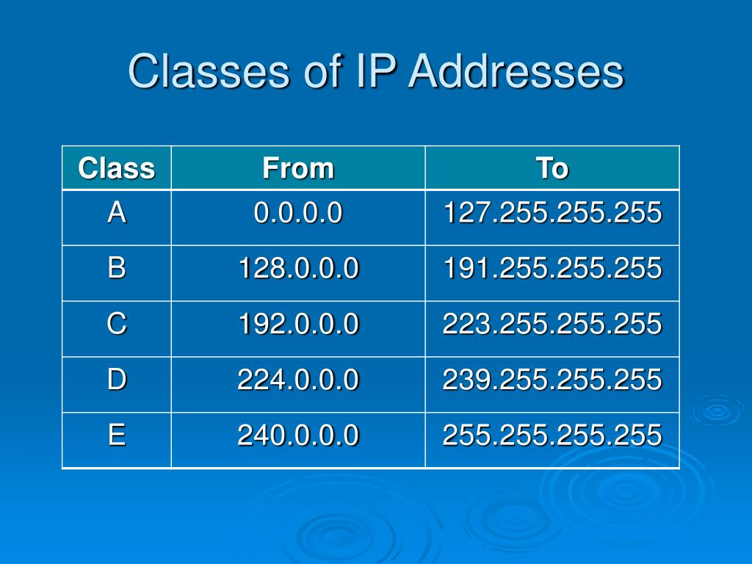
* Create vpc
* Select vpc only – with properties CidrBlock, InstanceTenancy, and Tags.
* The Cidr Block property specifies the IPv4 address range for the VPC
* Tags is a list of key-value pairs to apply to the VPC.
* The vpc will be created with the ipv4 adress :172.168.0.0/24
* Then navigate to the subnets then create the subnet
* Create public subnet give the the name and the ipv4 cidr block according to the range and g
* Same create the public subnets using create subnet.
* Create the route tables and onepublic and one private
* Add two public subnets and two private subnets to the public route table and private roue table

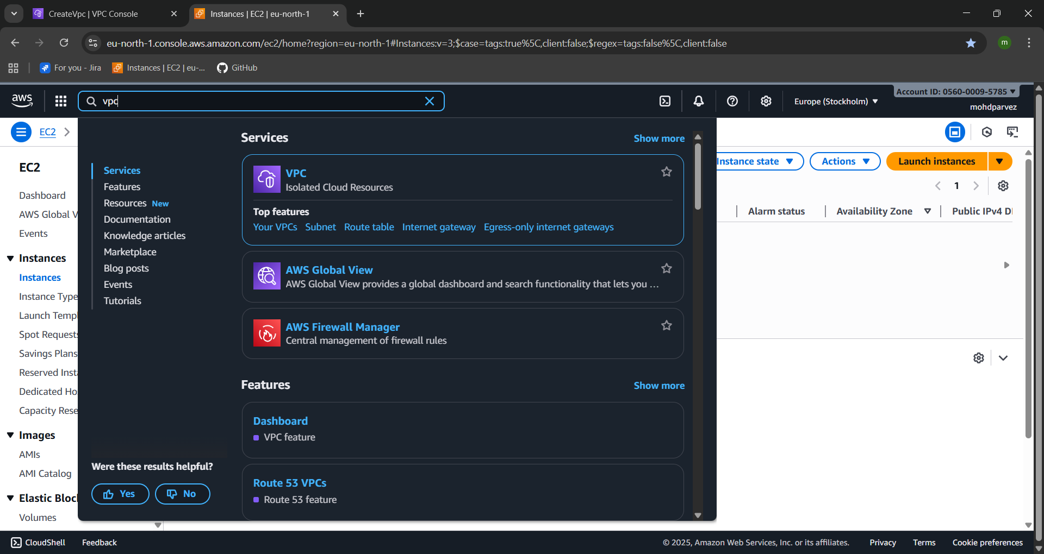

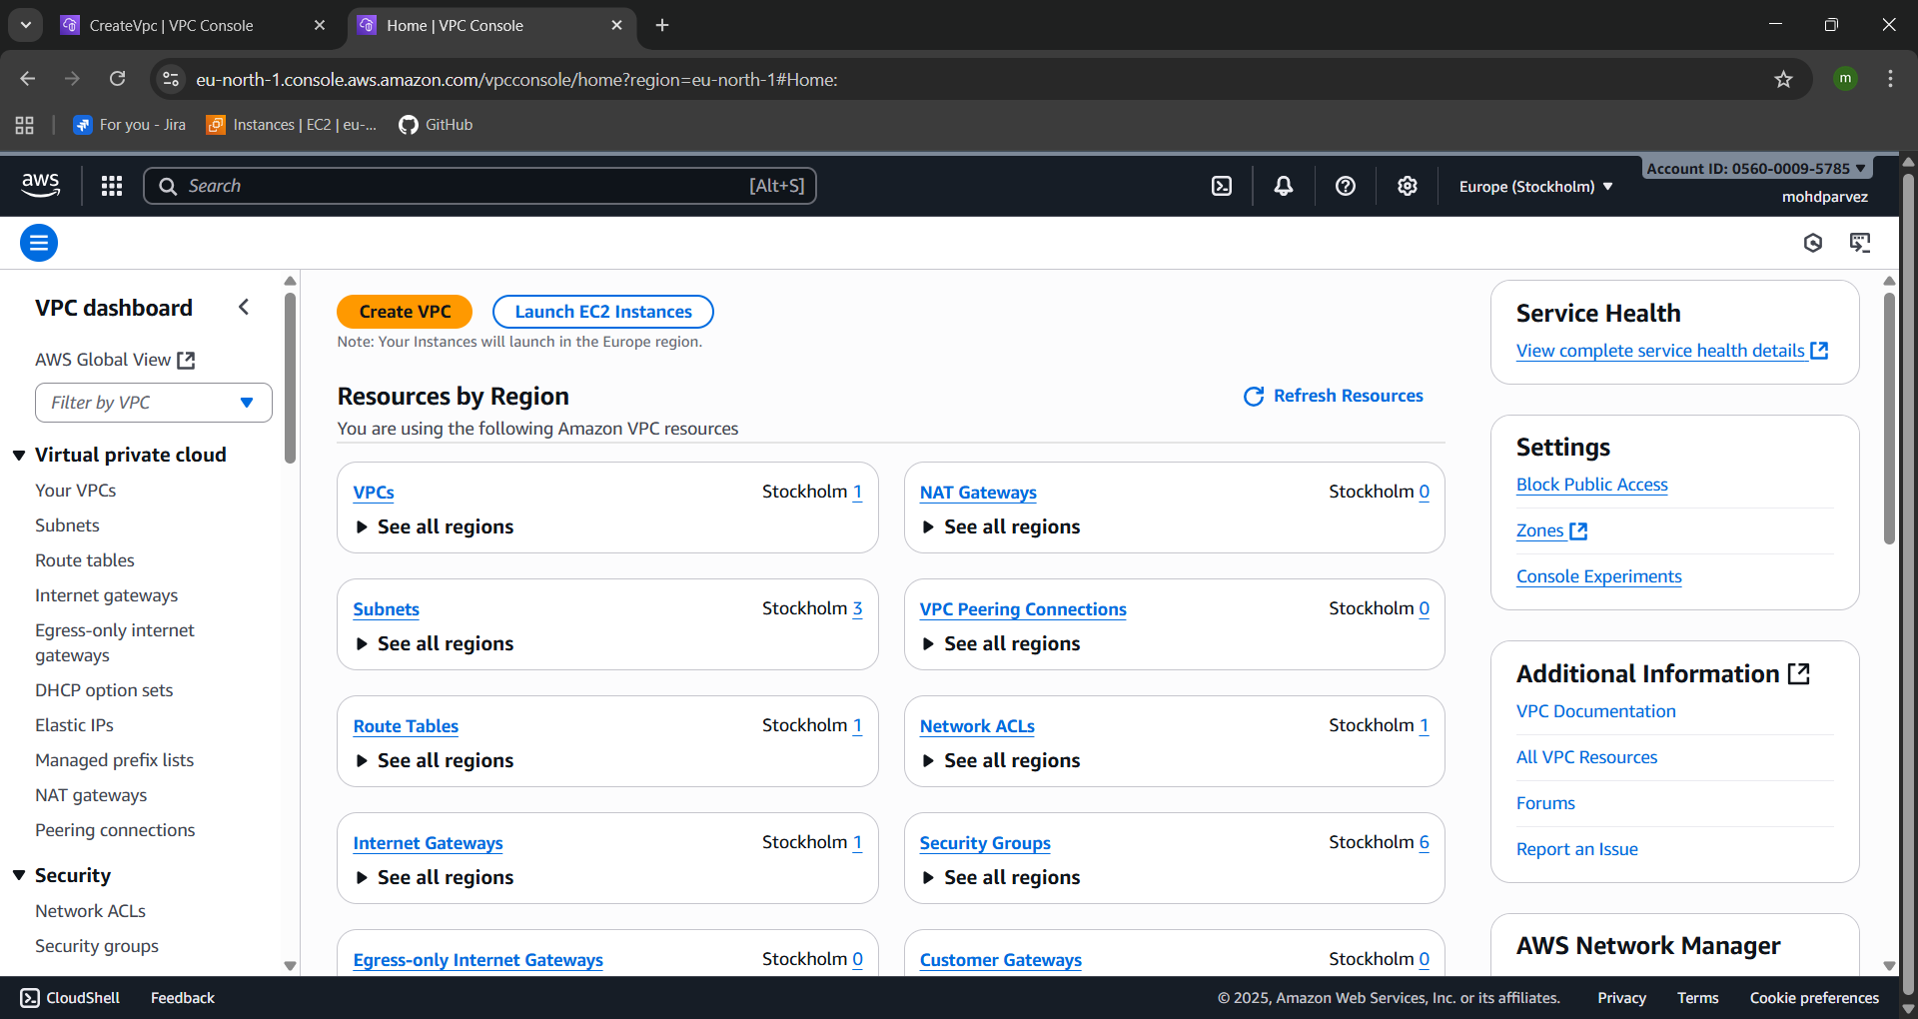

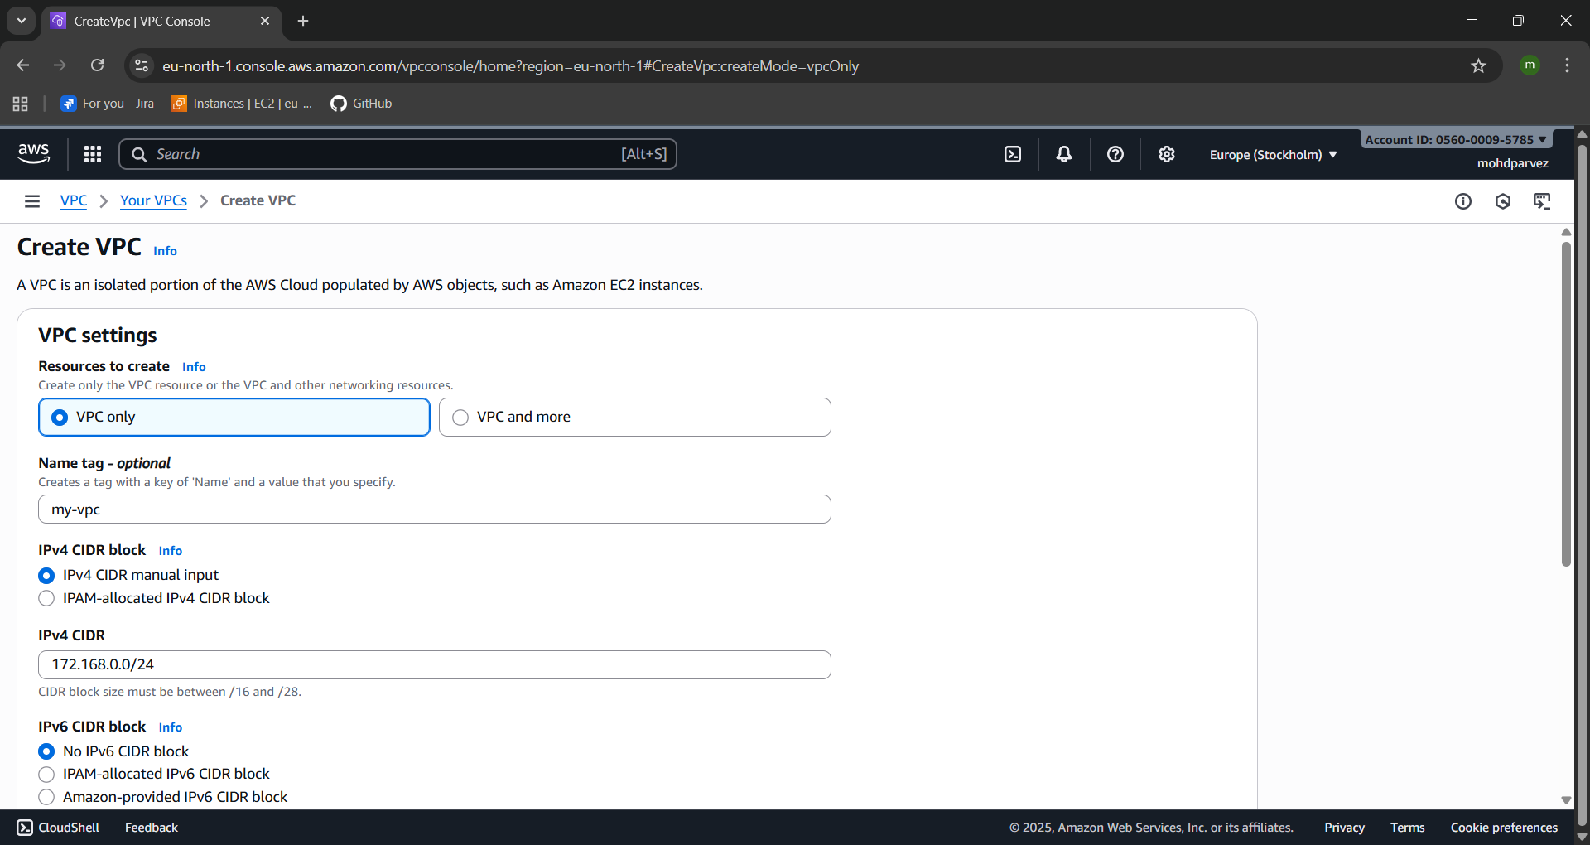

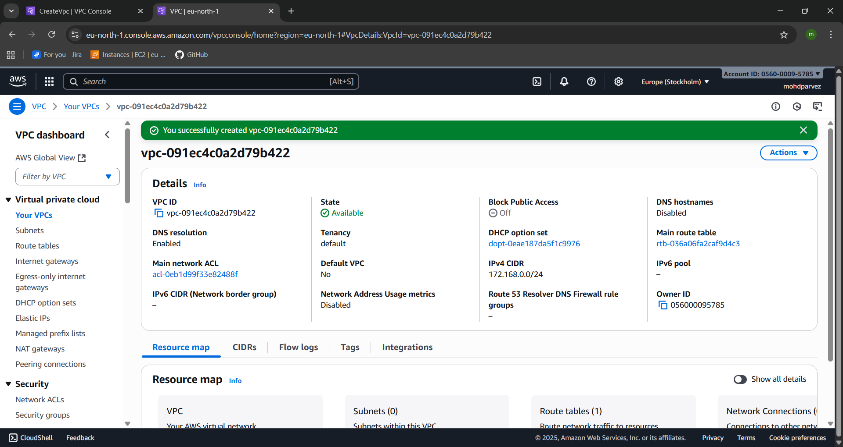 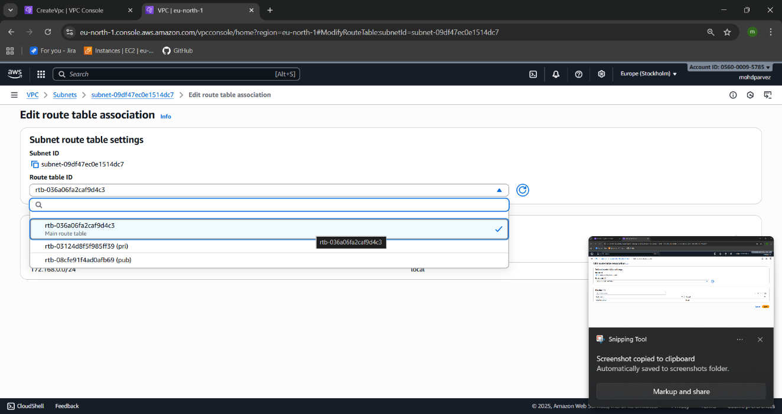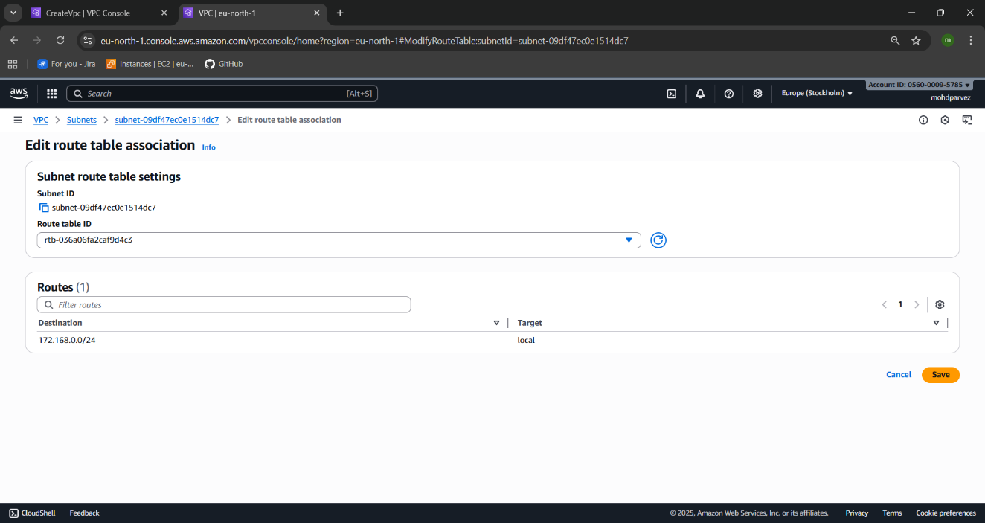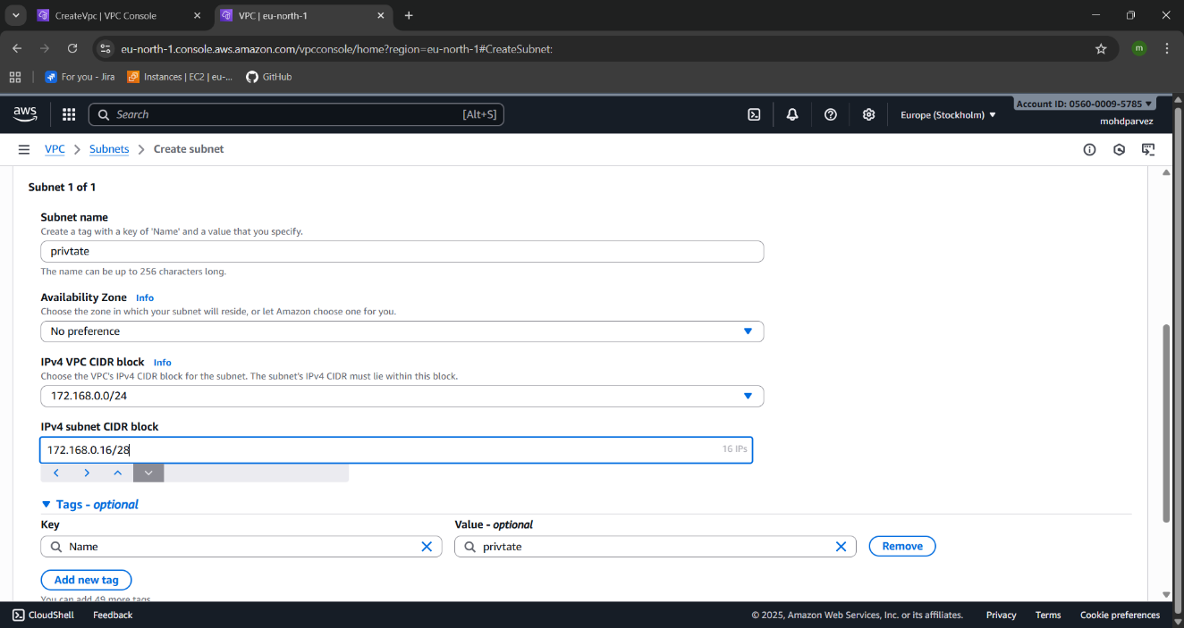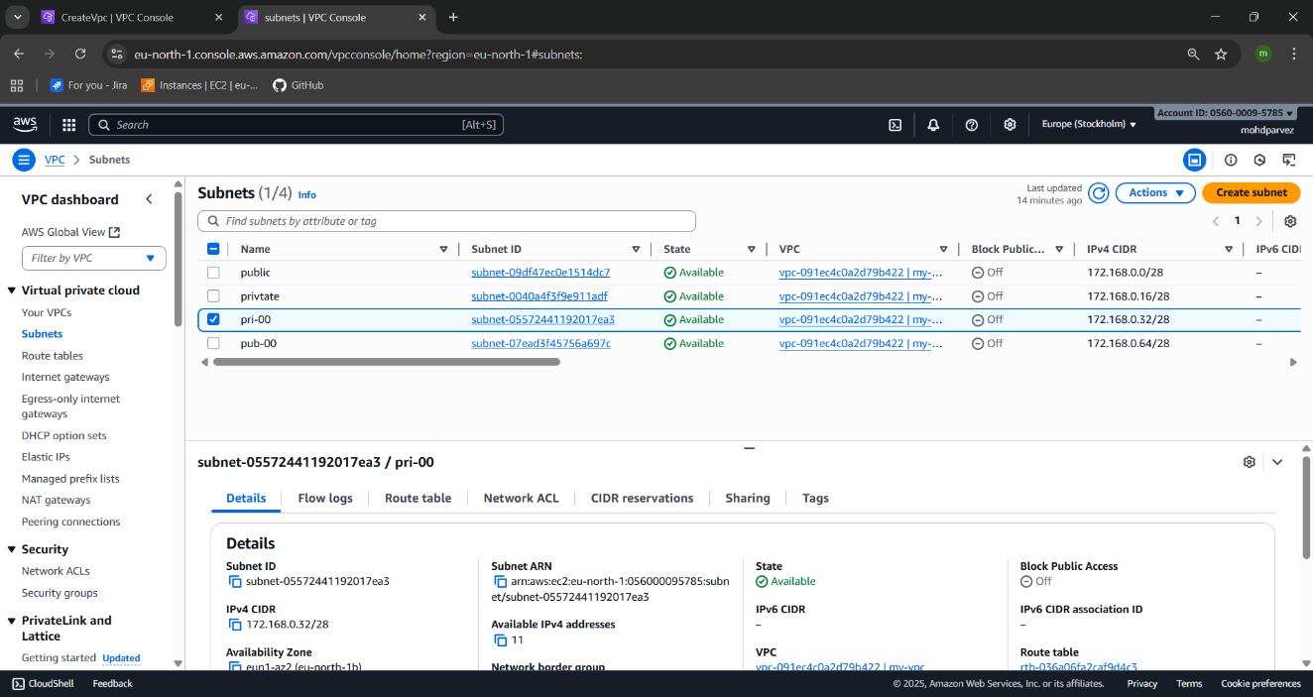

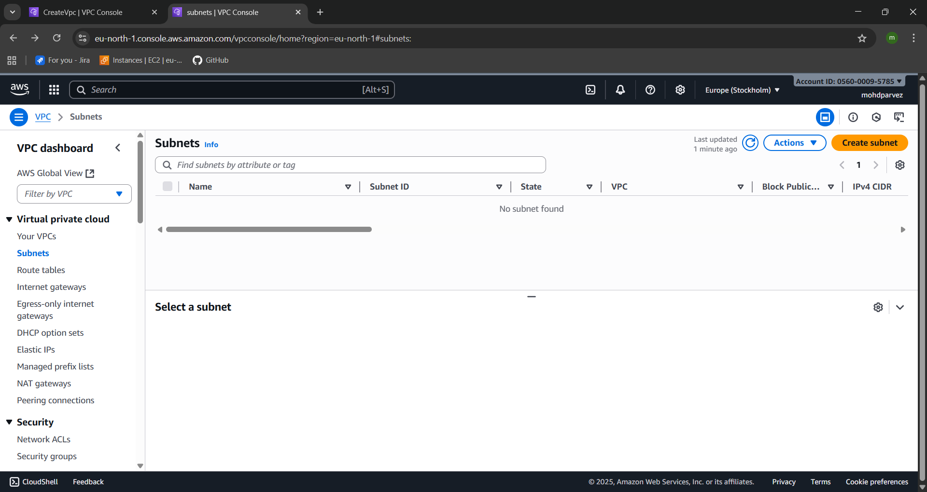 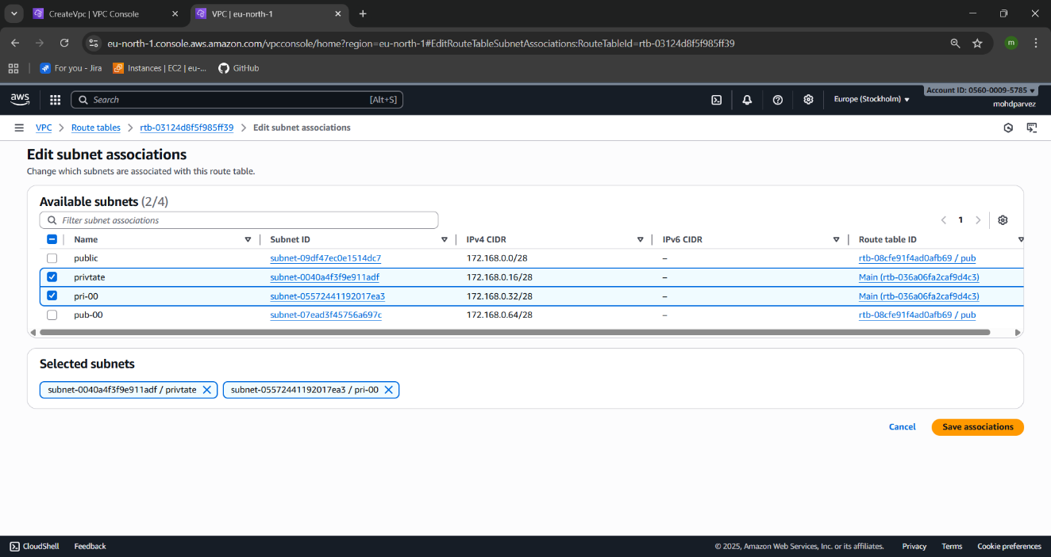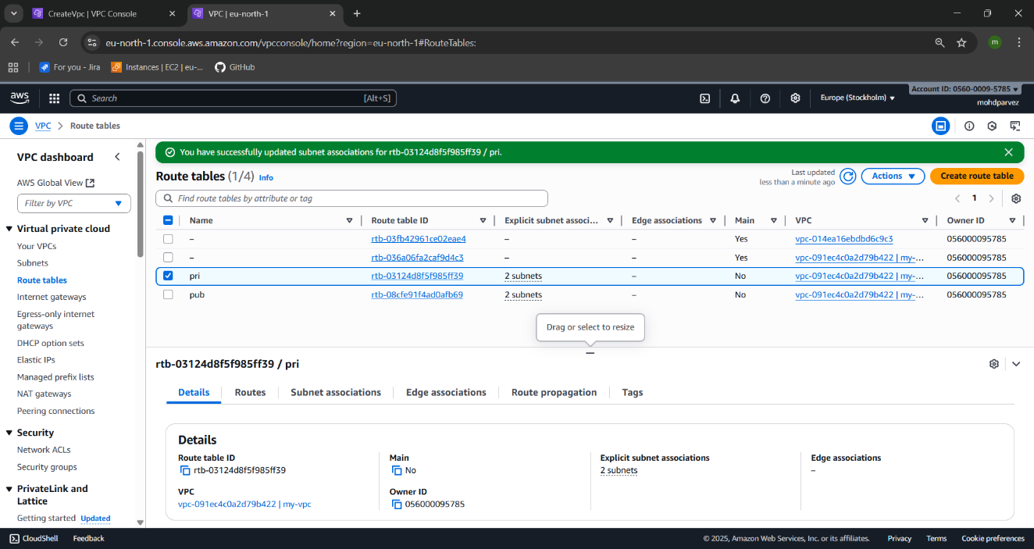

1. **Enable DNS Hostname in VPC.**

* Go to the vpc
* See the vpc you have created
* Go to to the actions
* Select edit vpc settings
* There you can see the dns setting
* Select the enable dns hostname

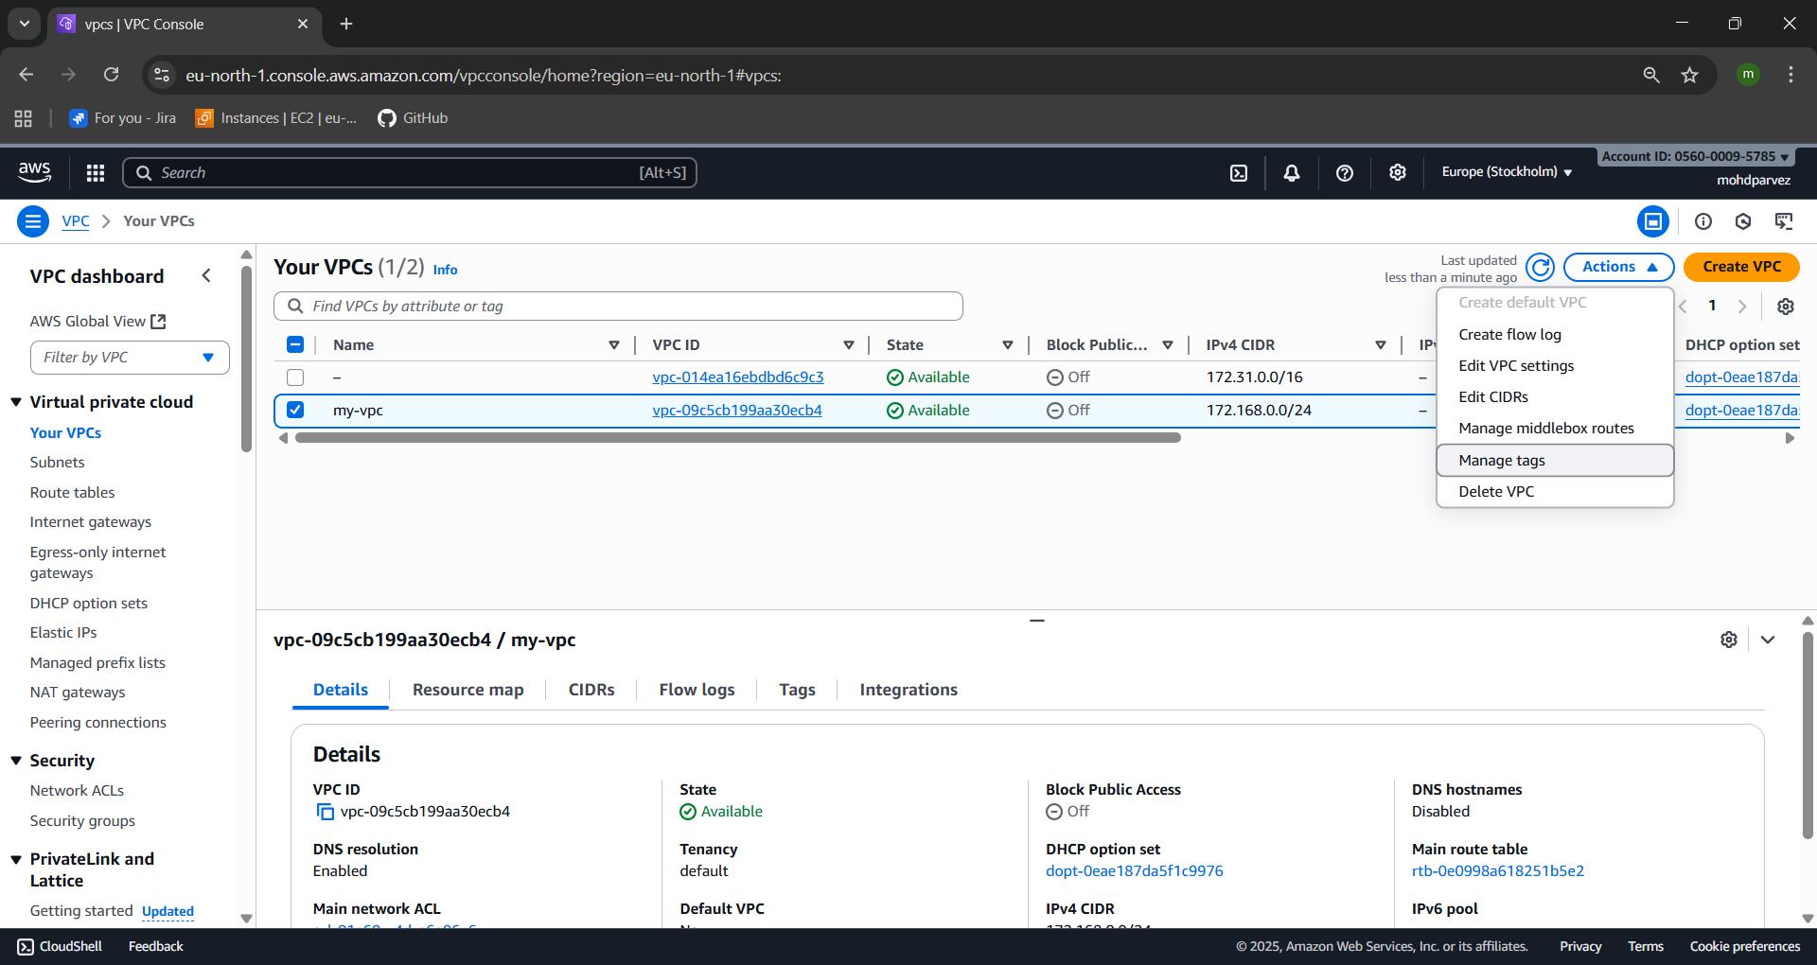



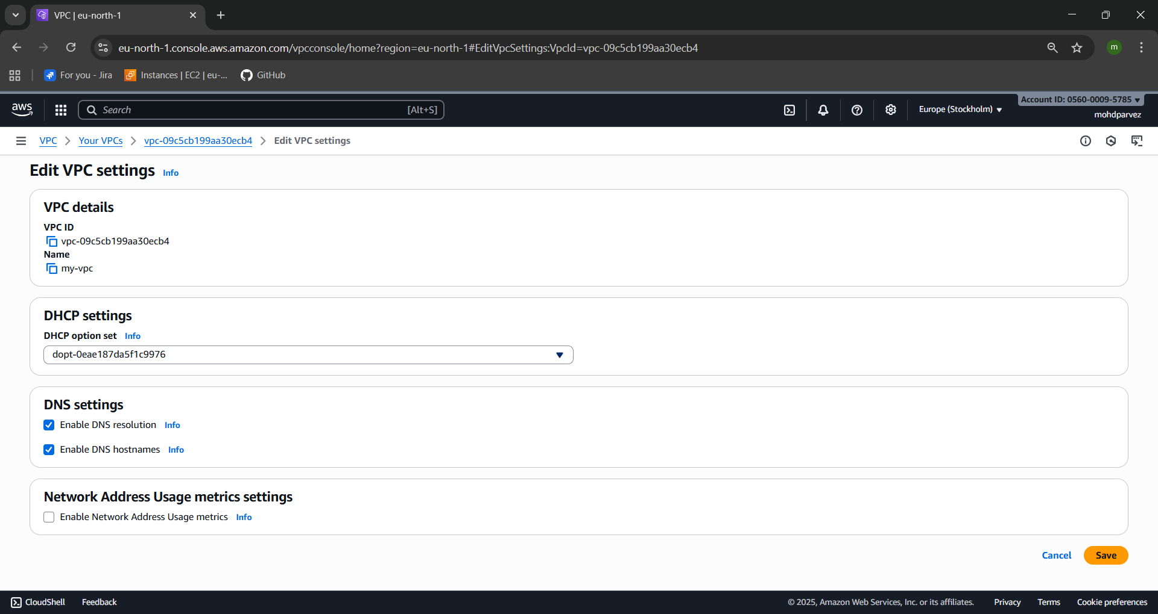



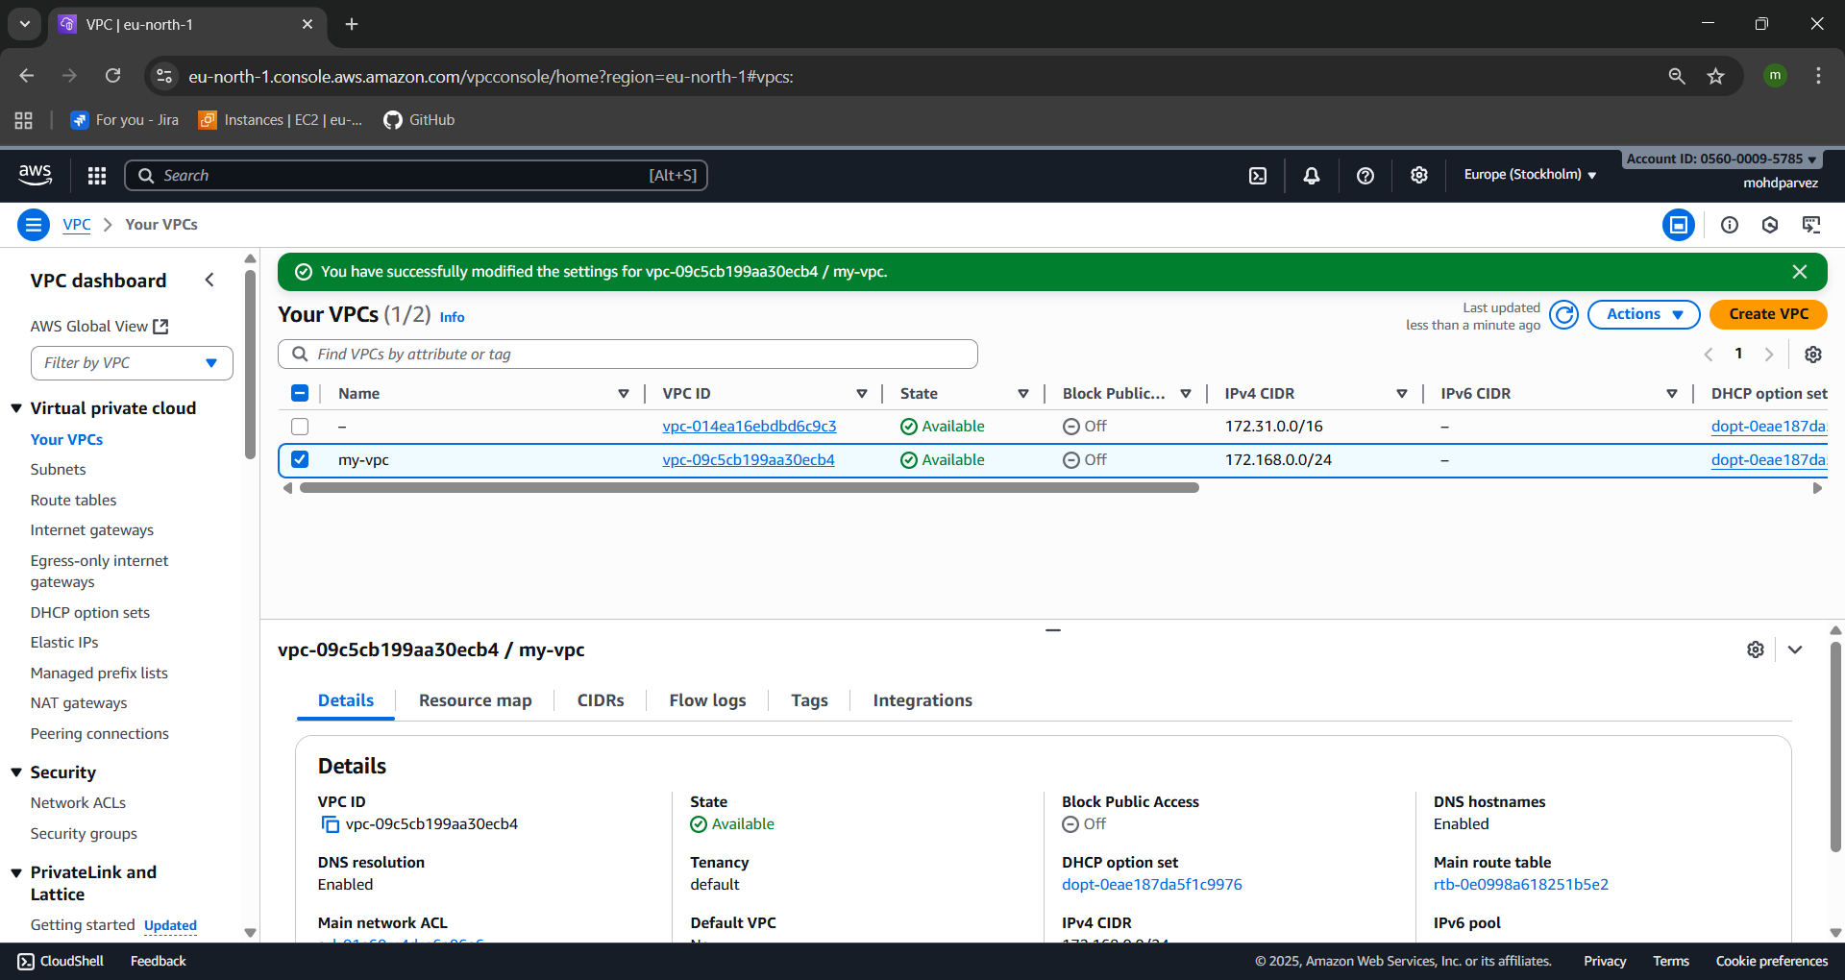



1. **Enable Auto Assign Public IP in 2 public subnets.**

* Got t to the subnets
* Select the subnet you want
* Got to the actions
* Select edit subnet setings
* Eable the auto assign public ipv4 adress to the subnet

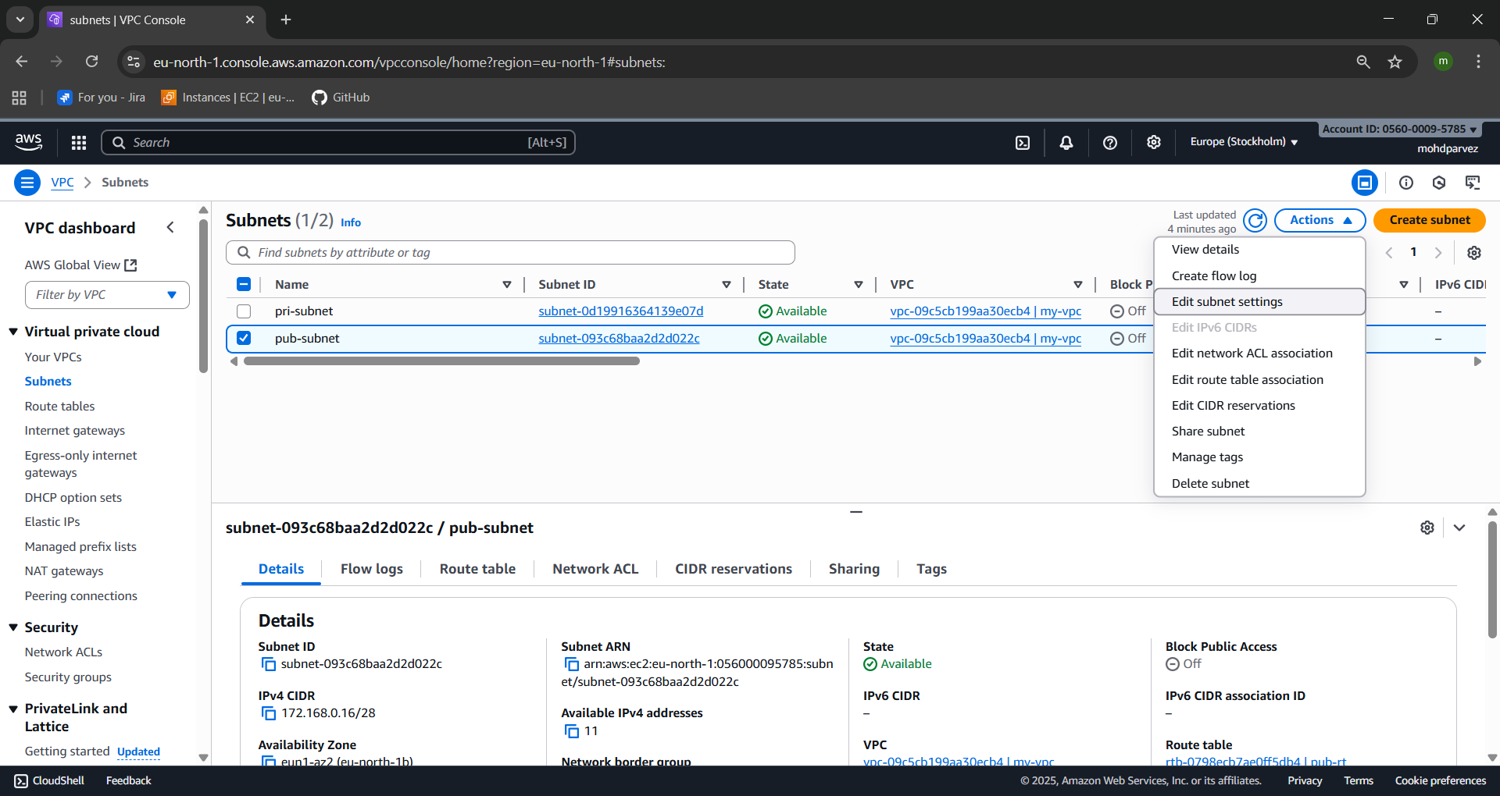

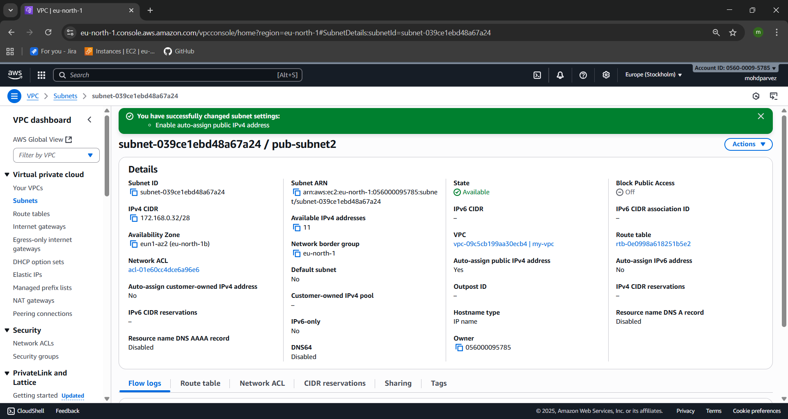

1. **Add 2 private subnets in private route table.**

* Go to the route table
* Create route table with the
* Give the name to route table :pri-RT
* And click and click on create route table
* The route table will be created
* The go to the subnets
* Below find the route table
* Select the edit route table association
* Add the public Route table to the private subnet
* Go to the route you can see the 2 subnets attached to the private route table

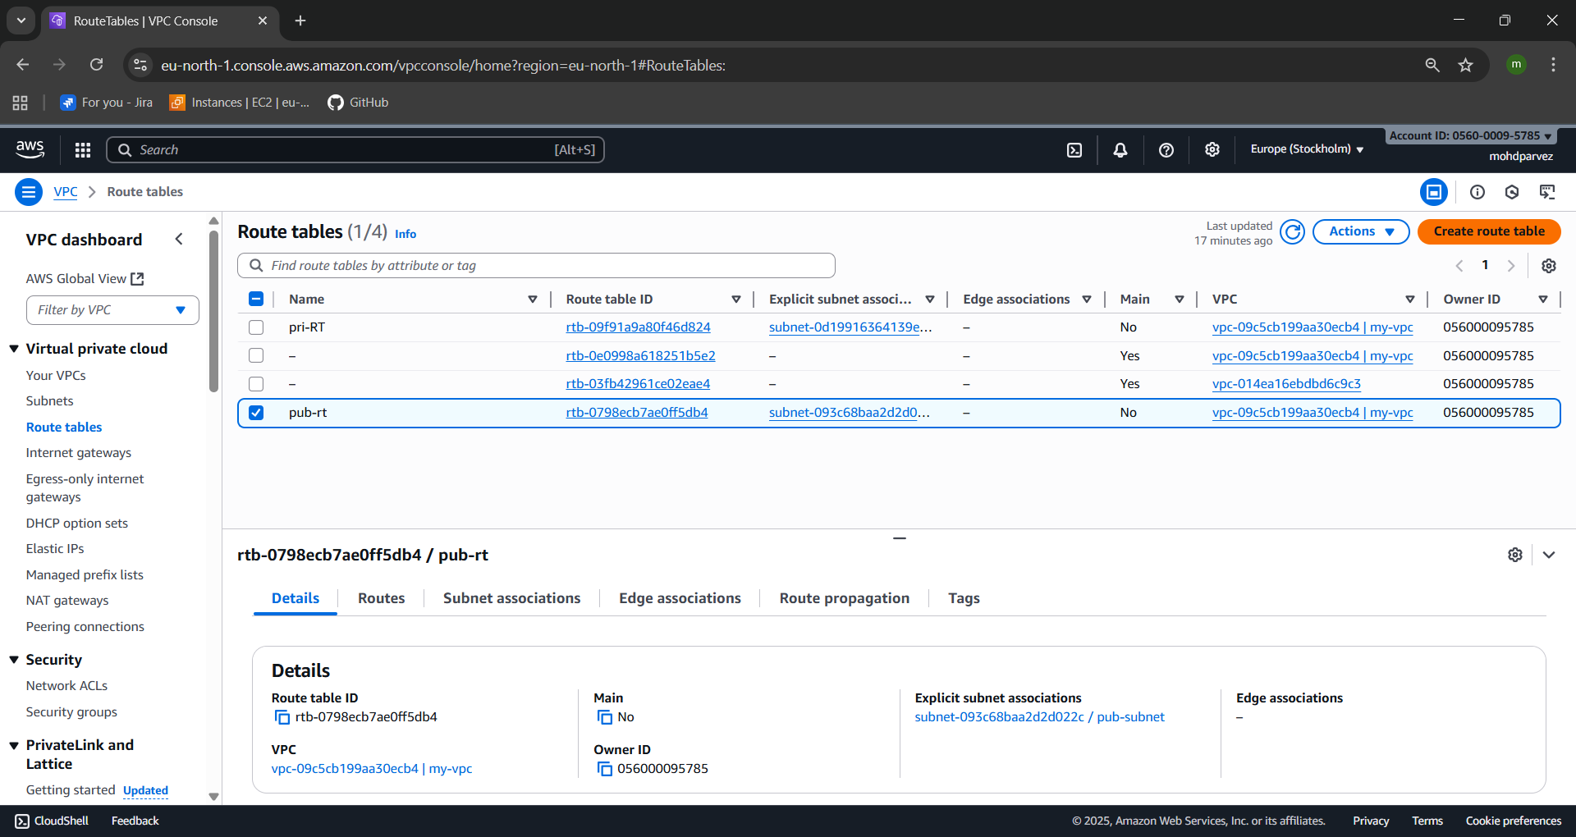

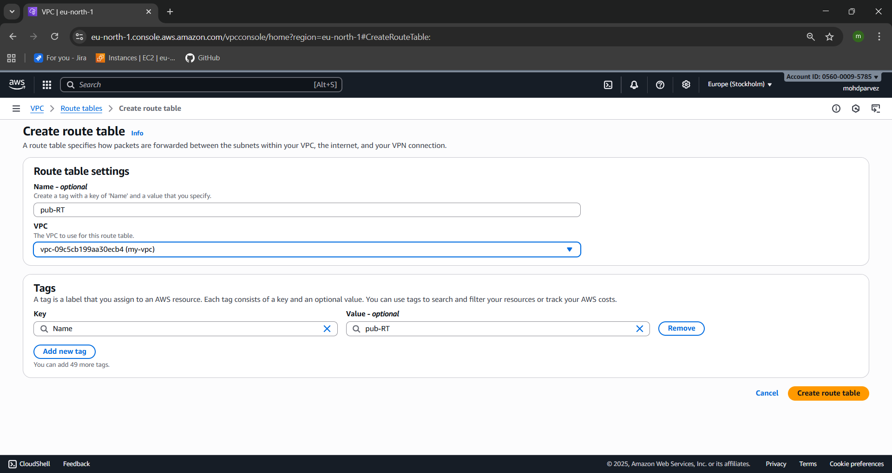

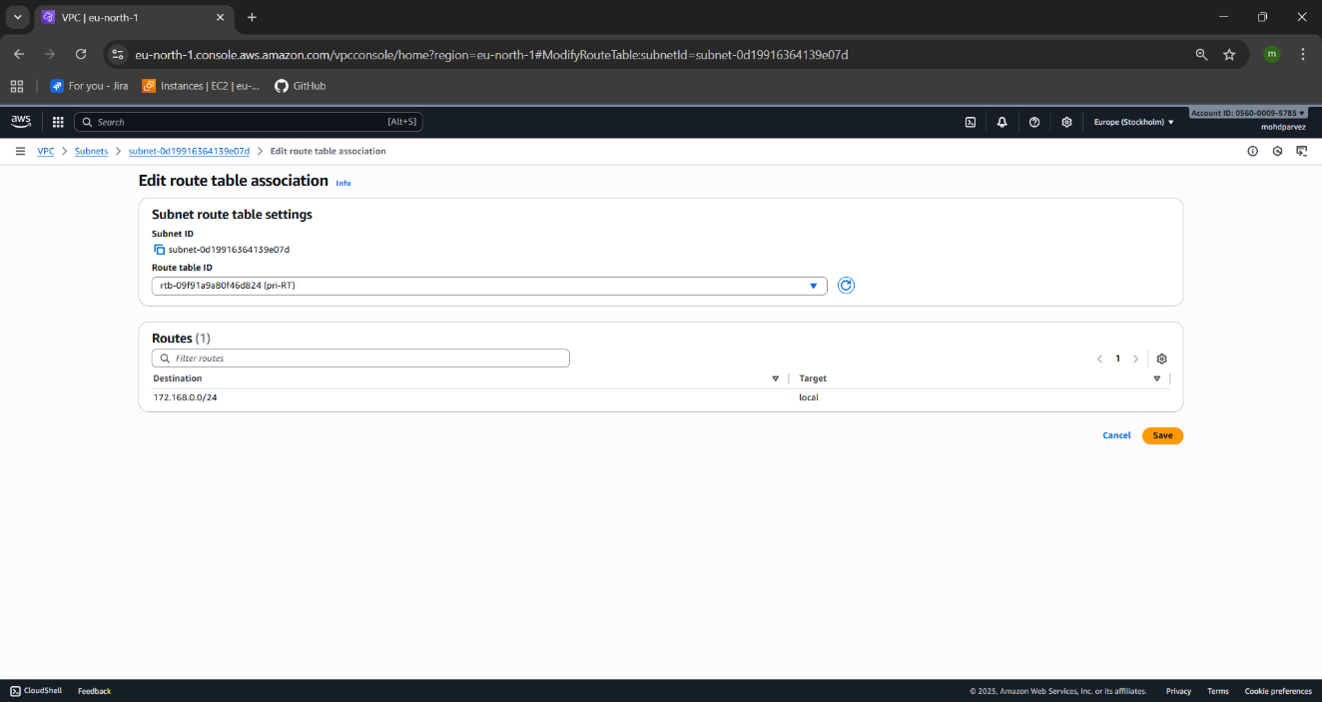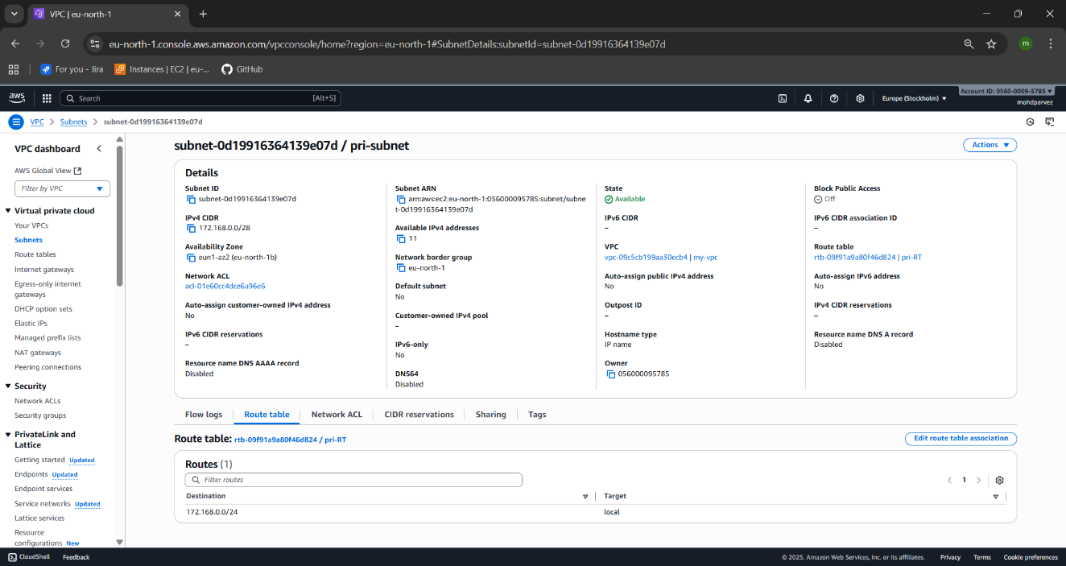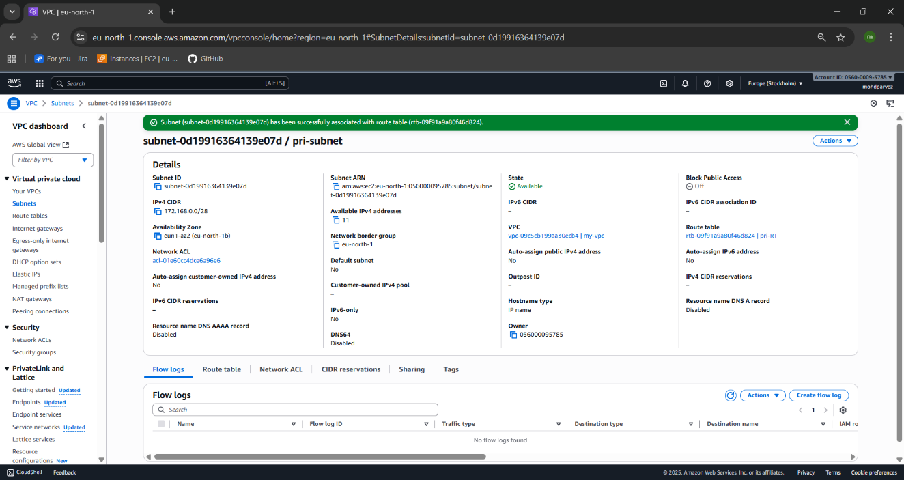



1. **Add 2 public subnets in public route table.**

* Create the route table
* That is the public route table : pub-RT
* Got ot the public subbnets
* Go to the route tables
* Edit route table association
* Add the pubic royte table to the subnet ad save ir
* The public subnets with the public route table will be initiated.
* Go to the route you can see the 2 subnets attached to the public route table

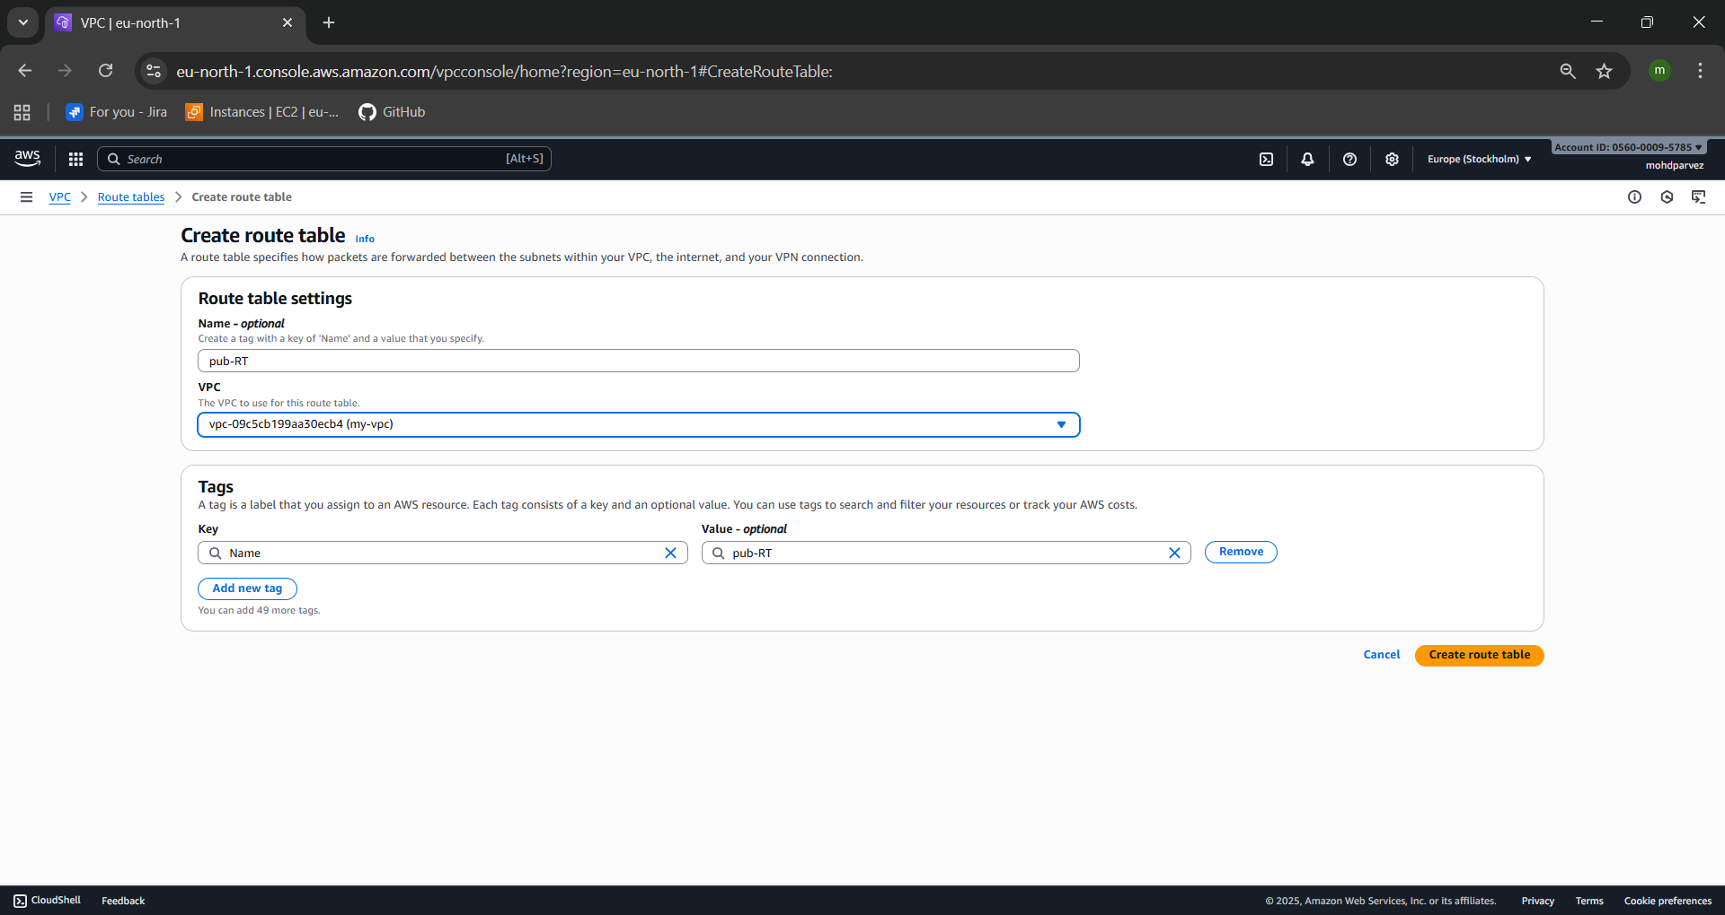

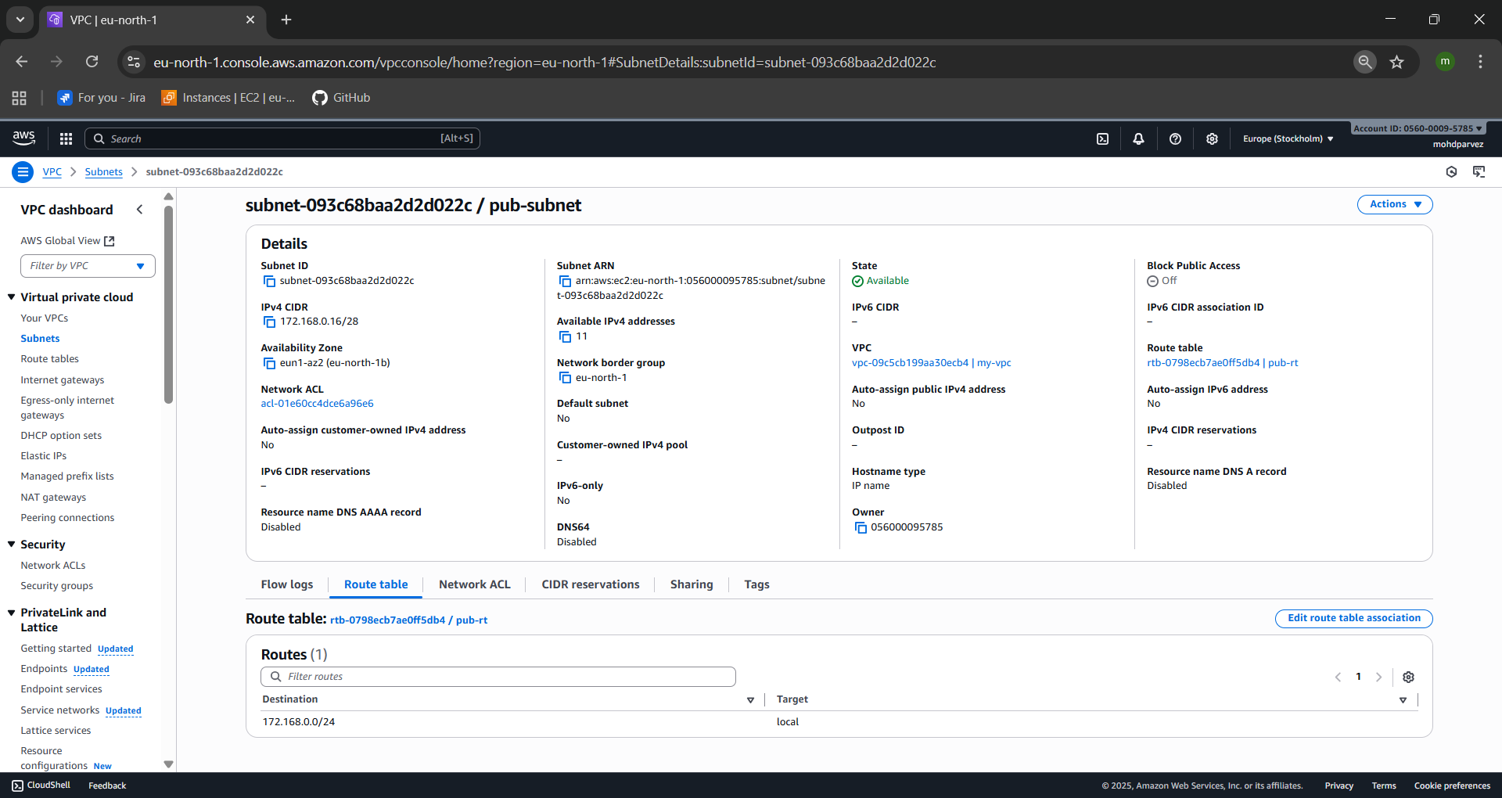



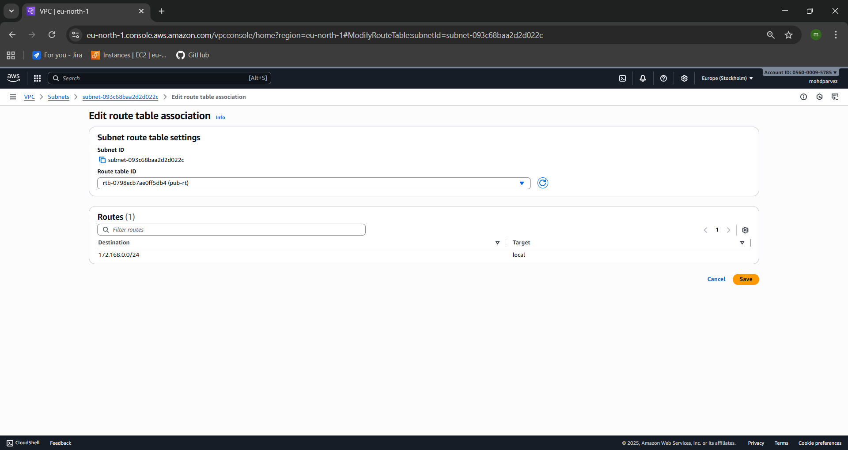



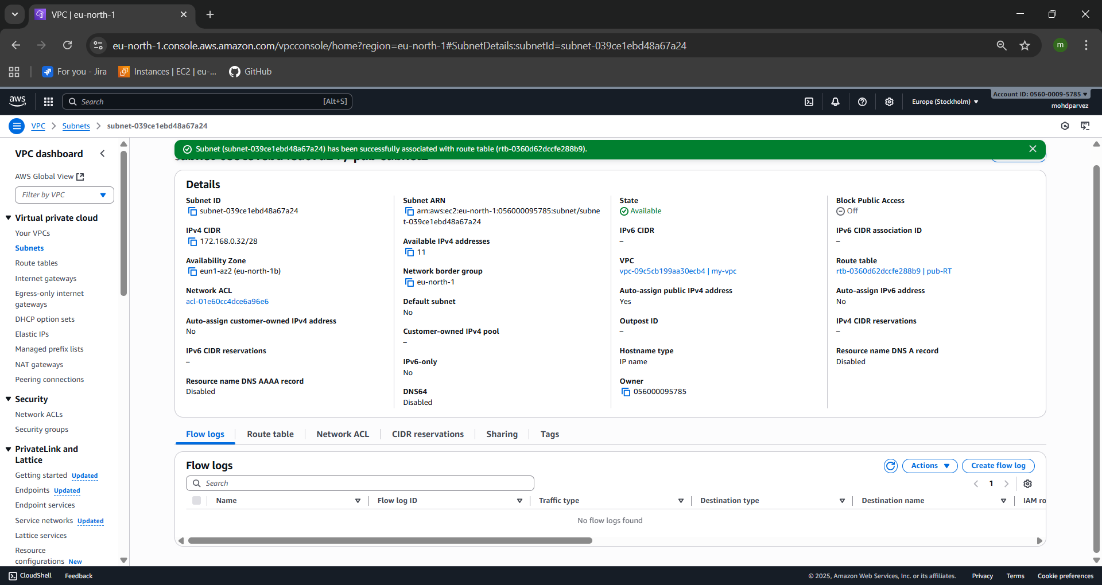



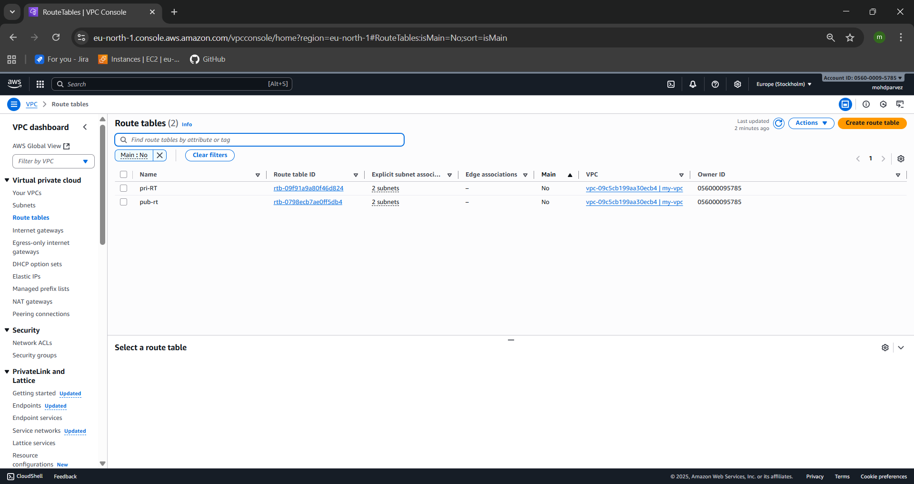

1. **Public route table will have the routes to internet and local.**

* You need to give the internet acess to the public subnet
* Go to internet gate way create internet gate way
* Select the internet gate way
* Attach the vpc you have created to the IGW
* Now navigate to the route
* Go to [public route
* Actions—edit routes—add internet gate way
* Now you can see the local and internet to the public route table.

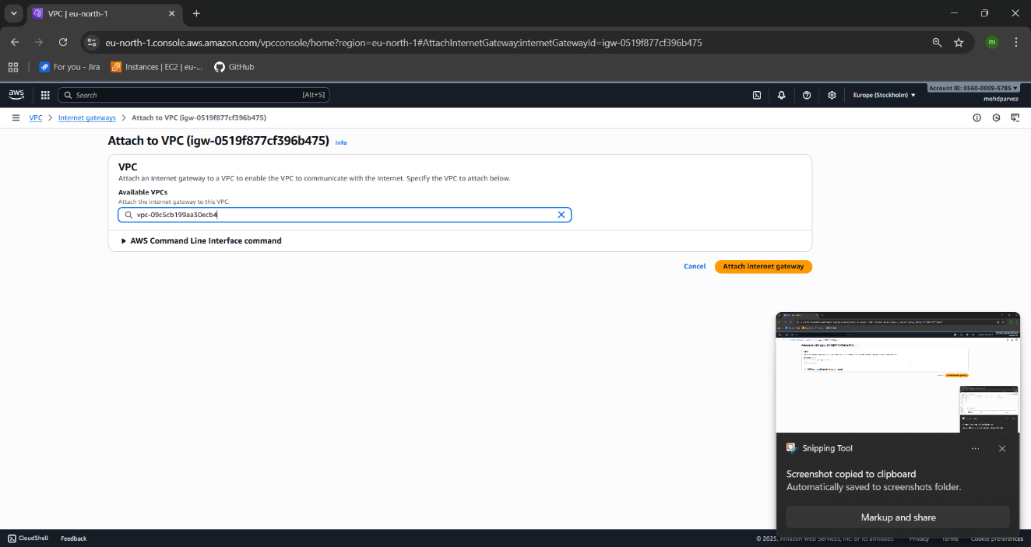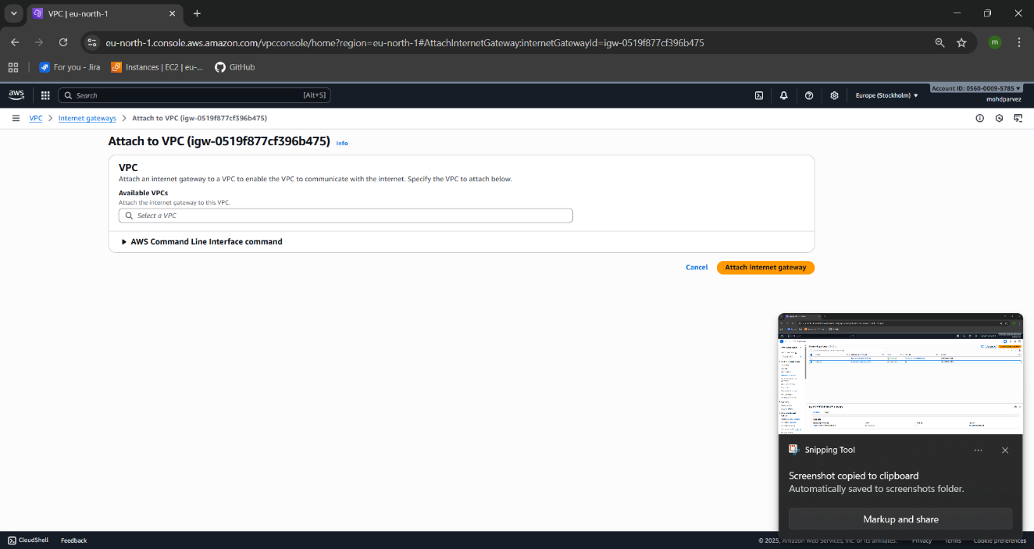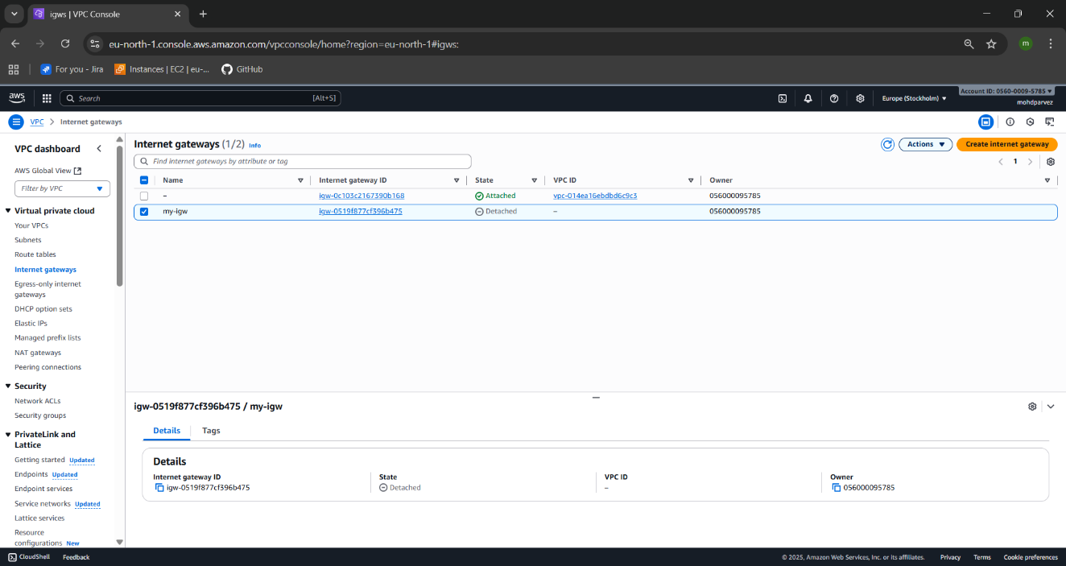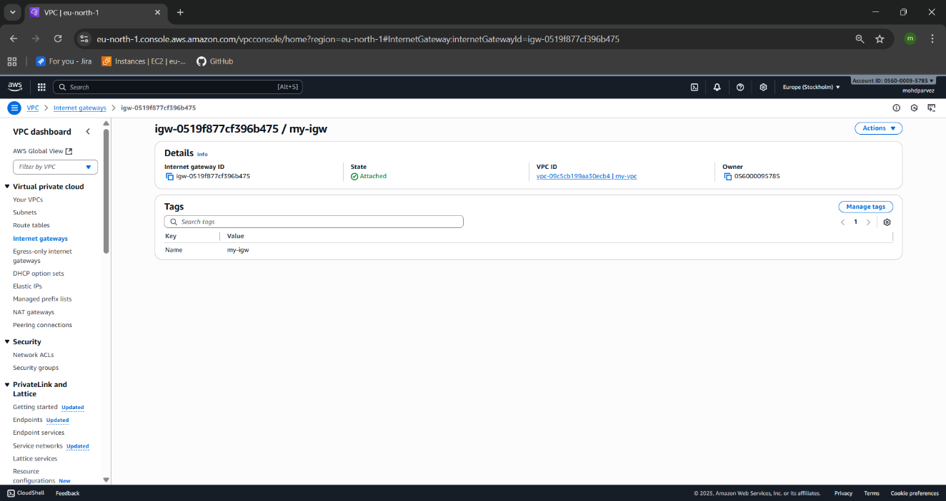



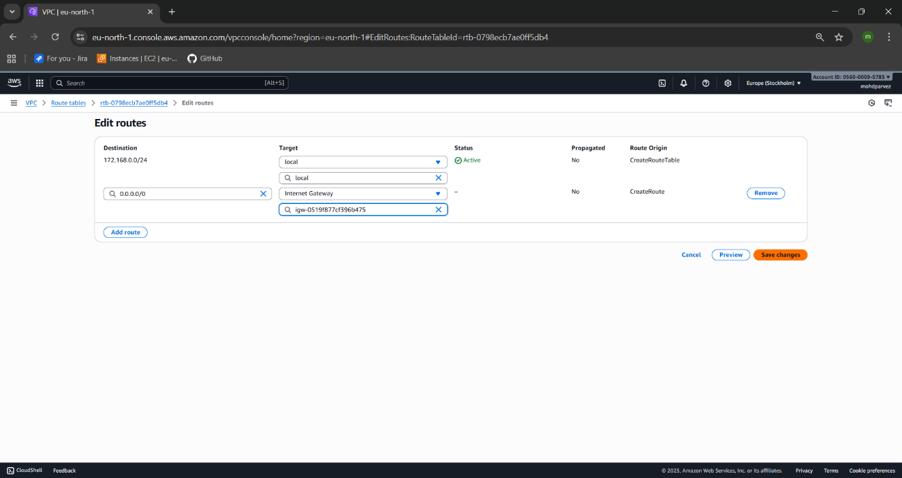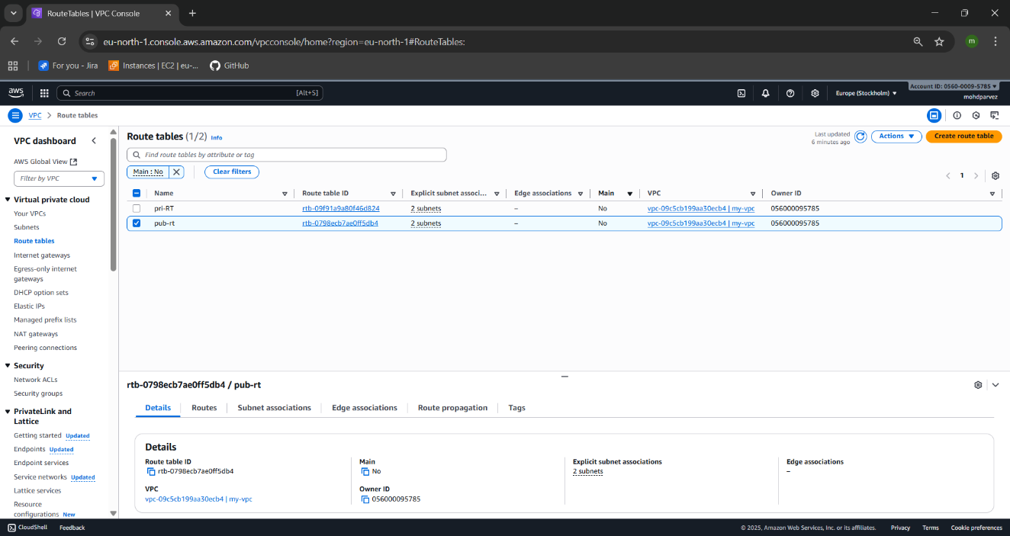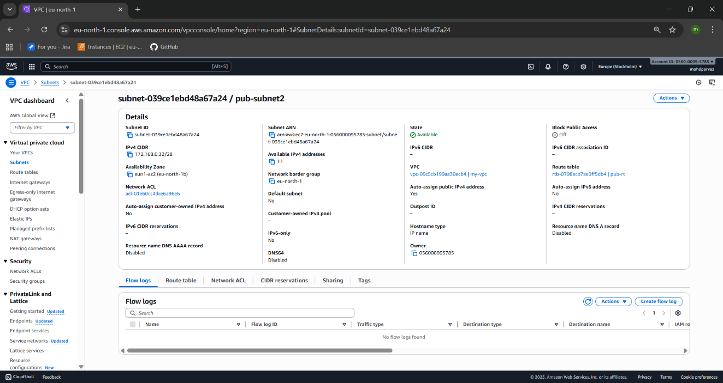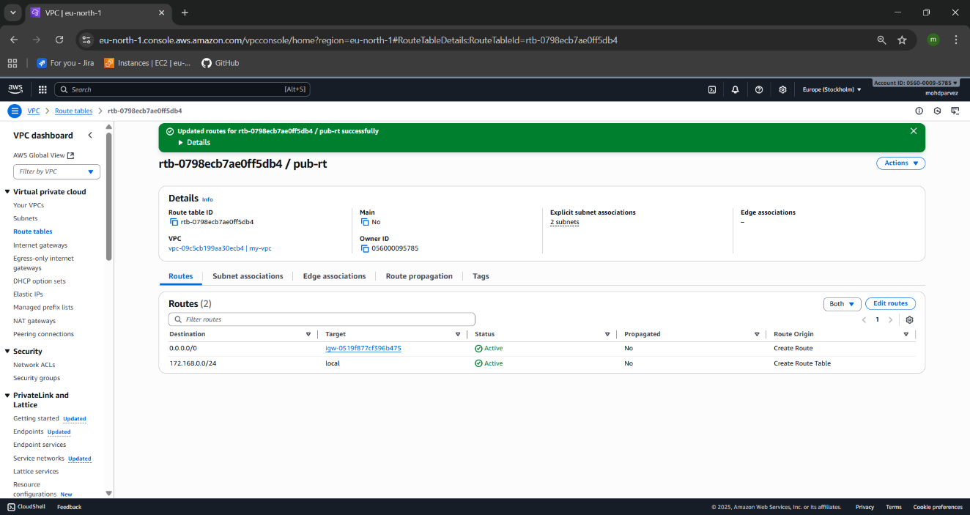



1. **Create EC2 in public subnet with t2.micro and install PHP.**

* Go to the ec2 launcj instance
* Give the name to the instance
* Select ami
* Select the instance type : t3.micro
* Select the key pair /create new pair
* In security groups –edit—select the vpc you created –select the public subnet
* Then scroll down got advance -navigate to the user data
* Write script to install php

#!/bin/bash

# PHP installation script

sudo dnf install -y php

php -v

* Then launch instance
* Then go to the location where the key pair has been downloaded
* Then connect to the instance : ssh -i “keypair.pem” ec2-user@ipv4 adress
* Check php -v : ypu can see the php ia installed.

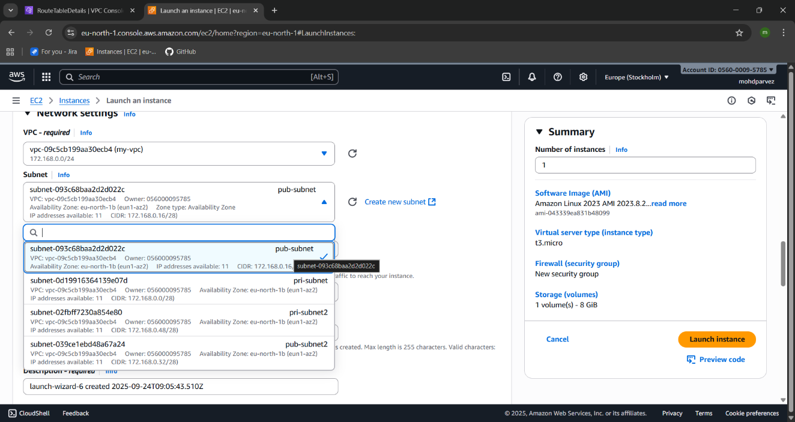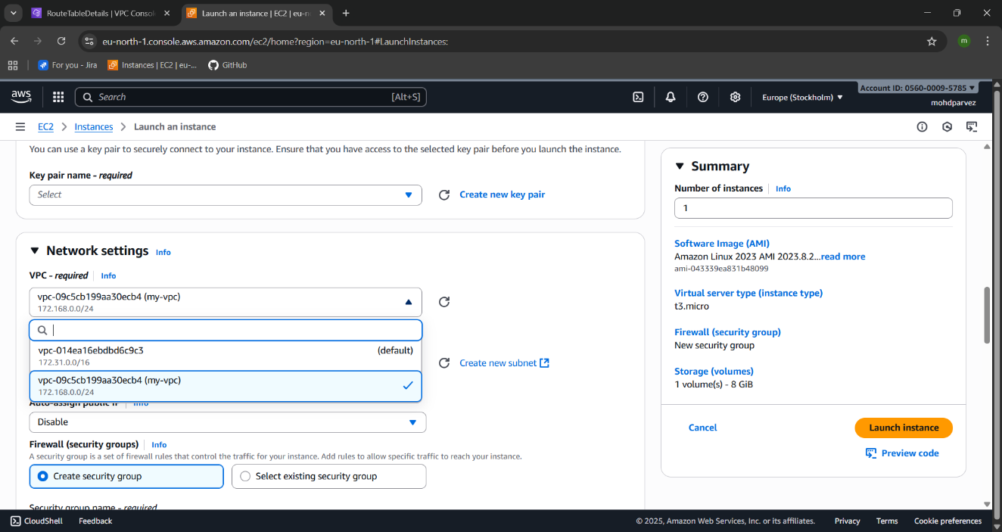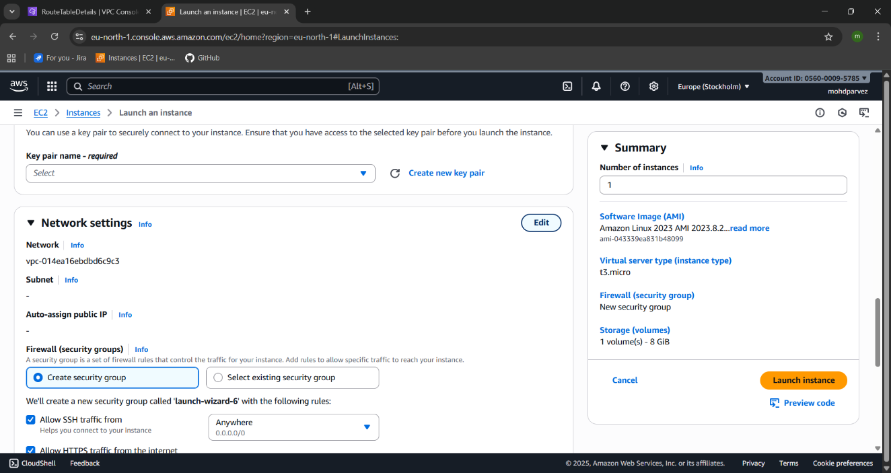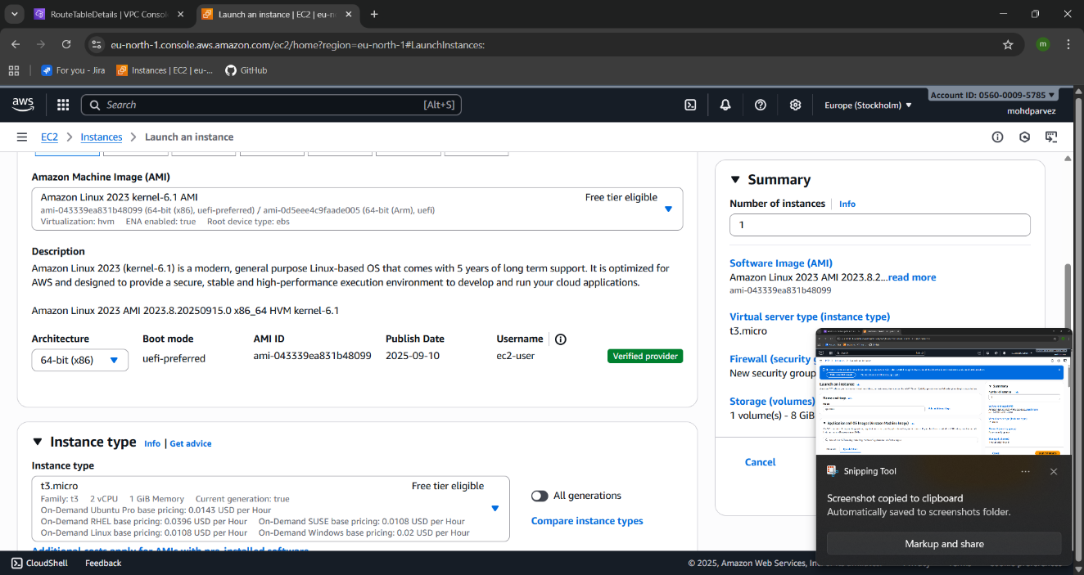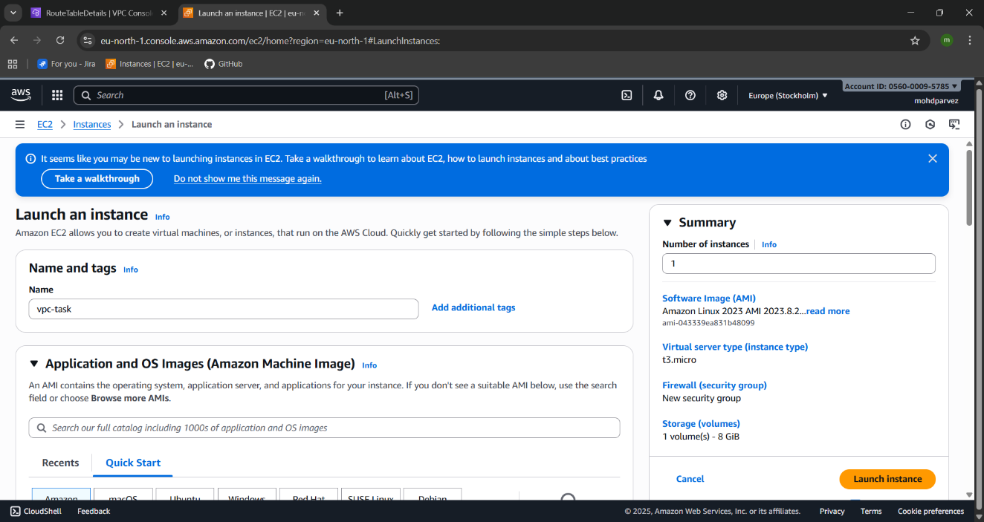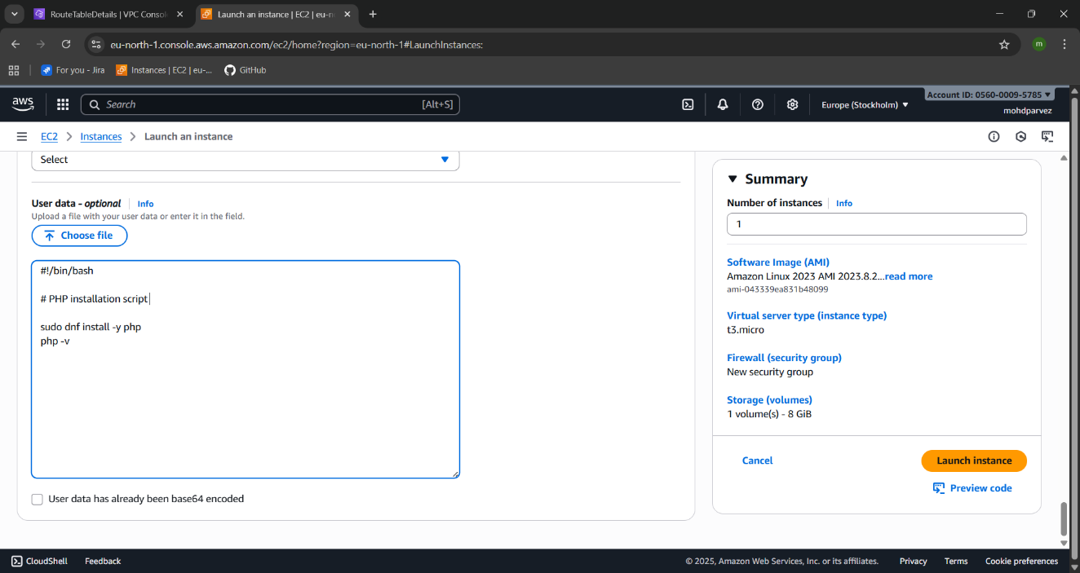

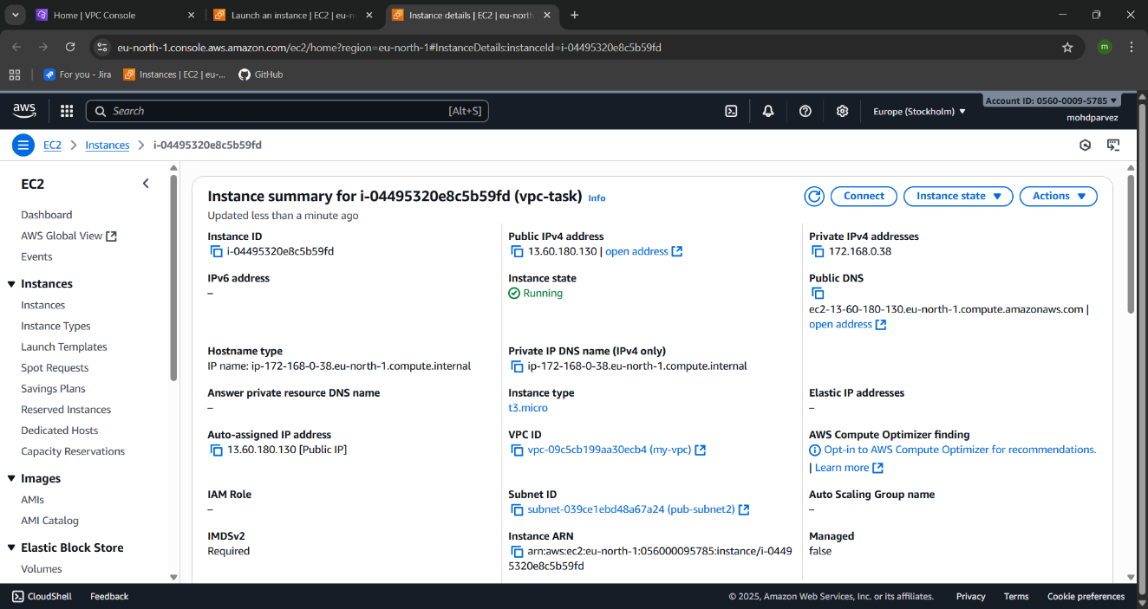

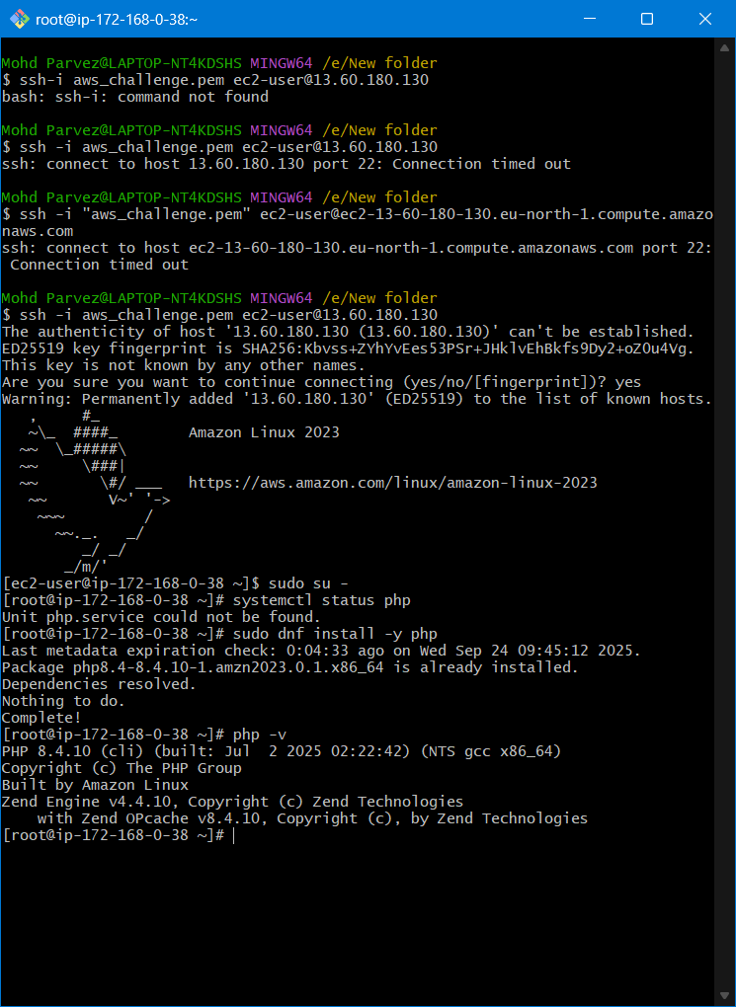

1. **Configure NAT gateway in public subnet and connect to private instance.**

* Go to the vpc – internet gateway –create internet gate way
* Go to route tables – public rout tables – routes –assign the internet gate way to the public route table .
* Then got to the nat gate ways which only allows the outbound rules
* Create nat gate way
* Assign nat gate way to the private route table.
* Now lauch one instance with the private subnet
* – edit security – select your vpc –select the private subnet .
* Lauch one ec2 instance using same vpc and public subnet
* No connect to the public subnet instance
* Then switch to root user
* Copy the pem key and create .pem file in the machine
* Then give permission chmod 400 “key.pem”
* Then connect to the private instance now

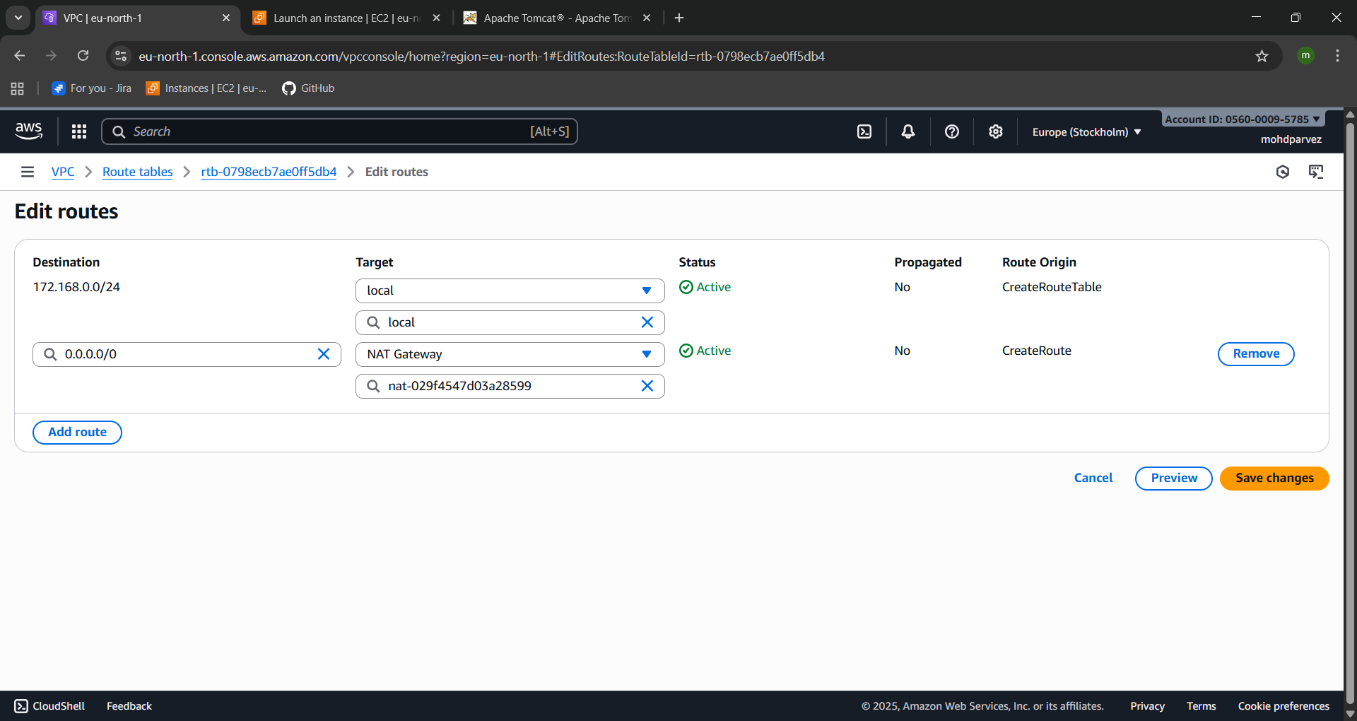

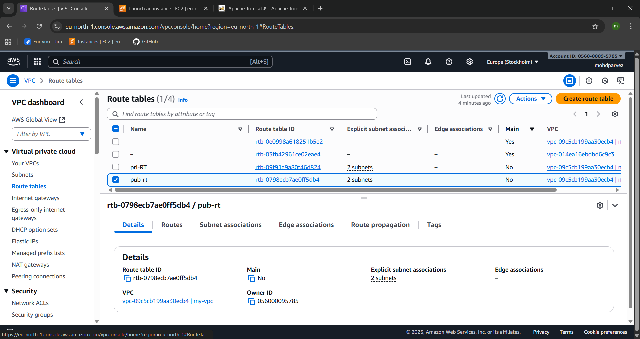

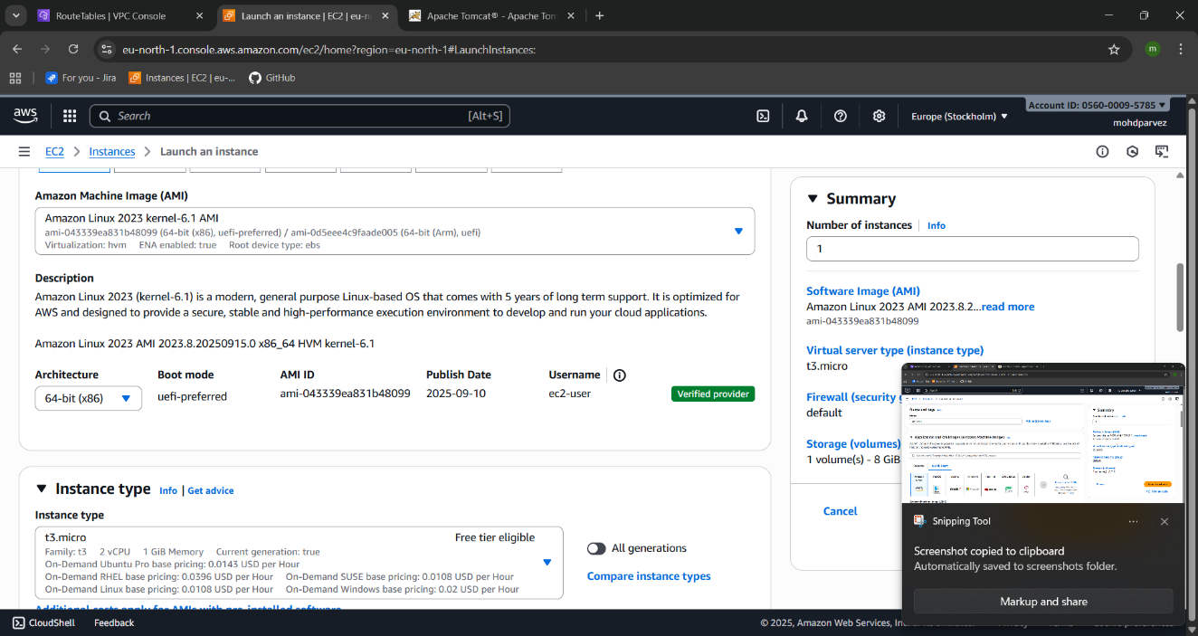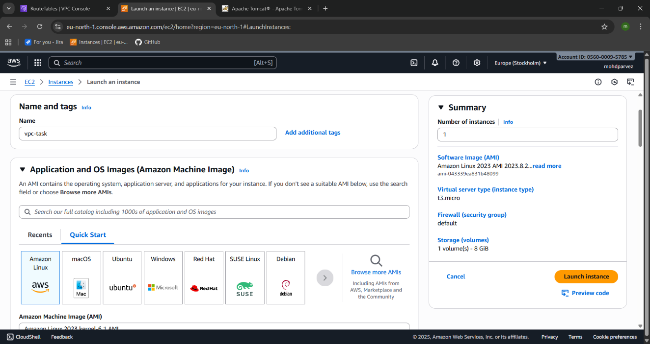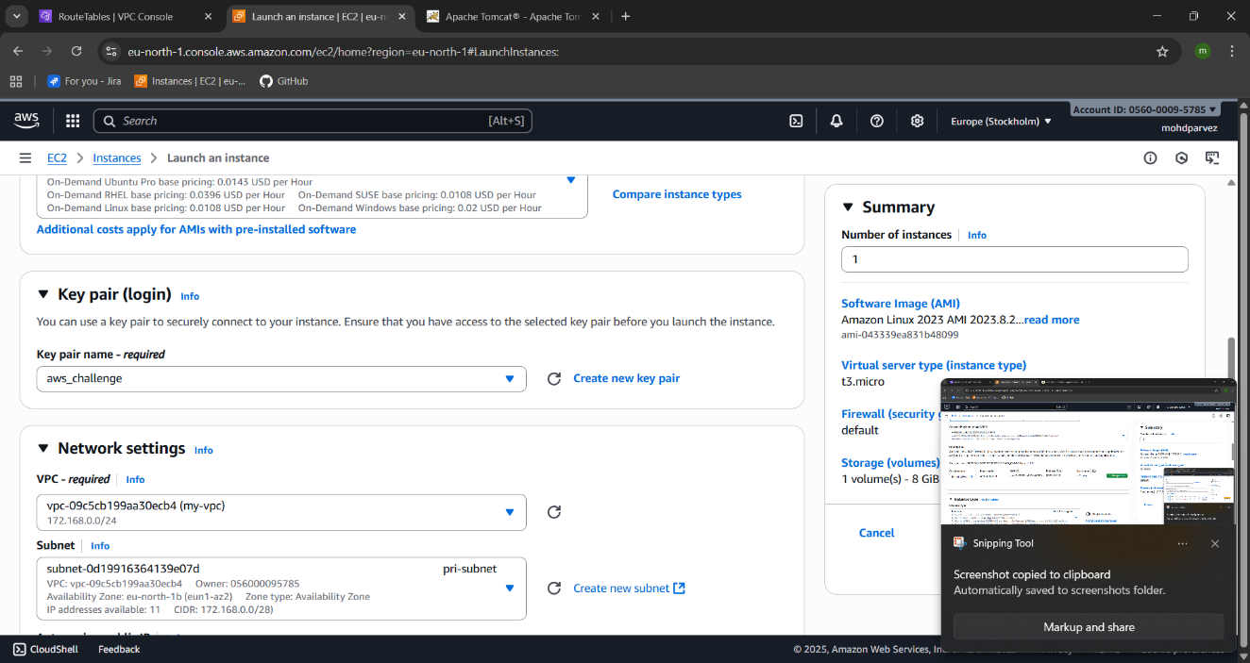

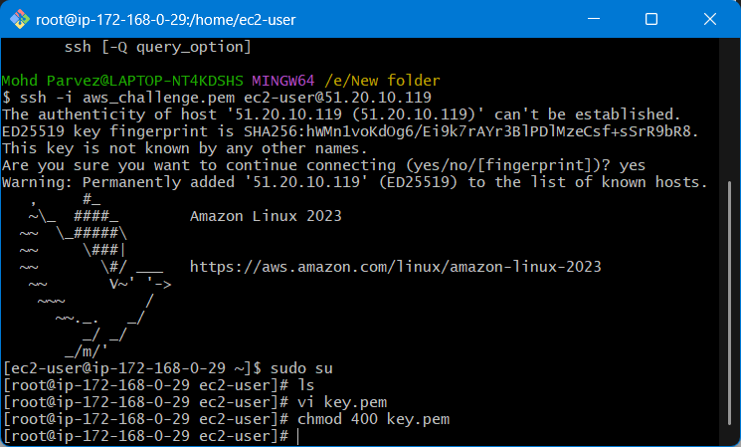

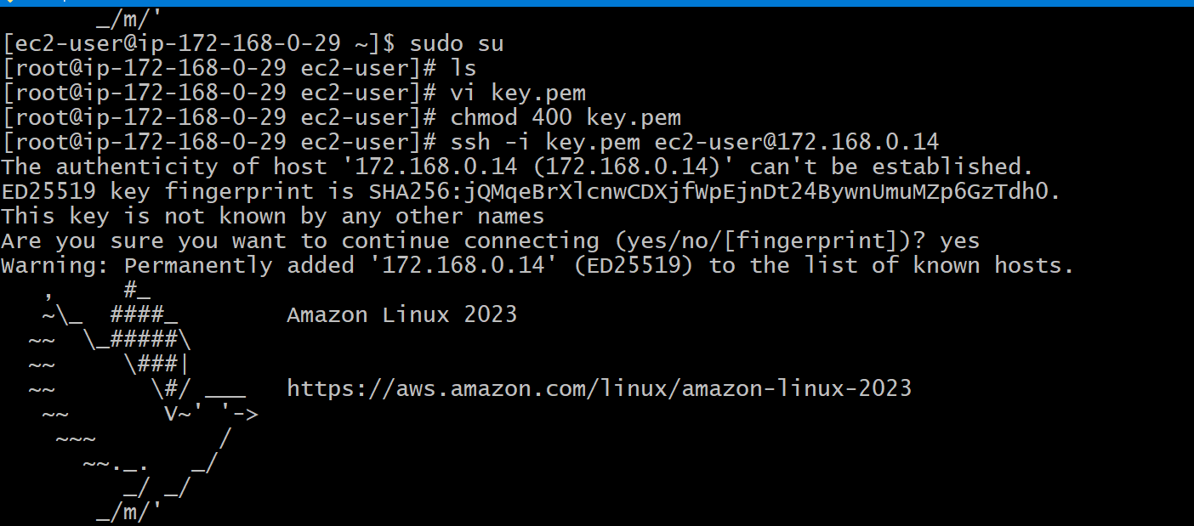

1. **Install Apache Tomcat in private EC2 and deploy a sample app.**
2. **Configure VPC flow logs and store the logs in S3 and CloudWatch.**